LIBRARY MANAGEMENT SYSTEM
Library Branch Master – Entry Form
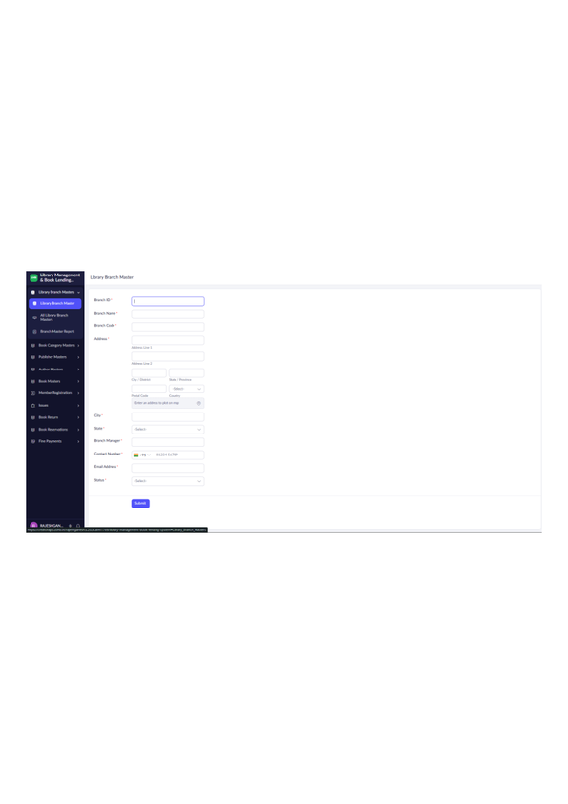
Figure 1: Library Branch Master – Entry Form

LIBRARY MANAGEMENT SYSTEM
All Library Branch Masters – Report
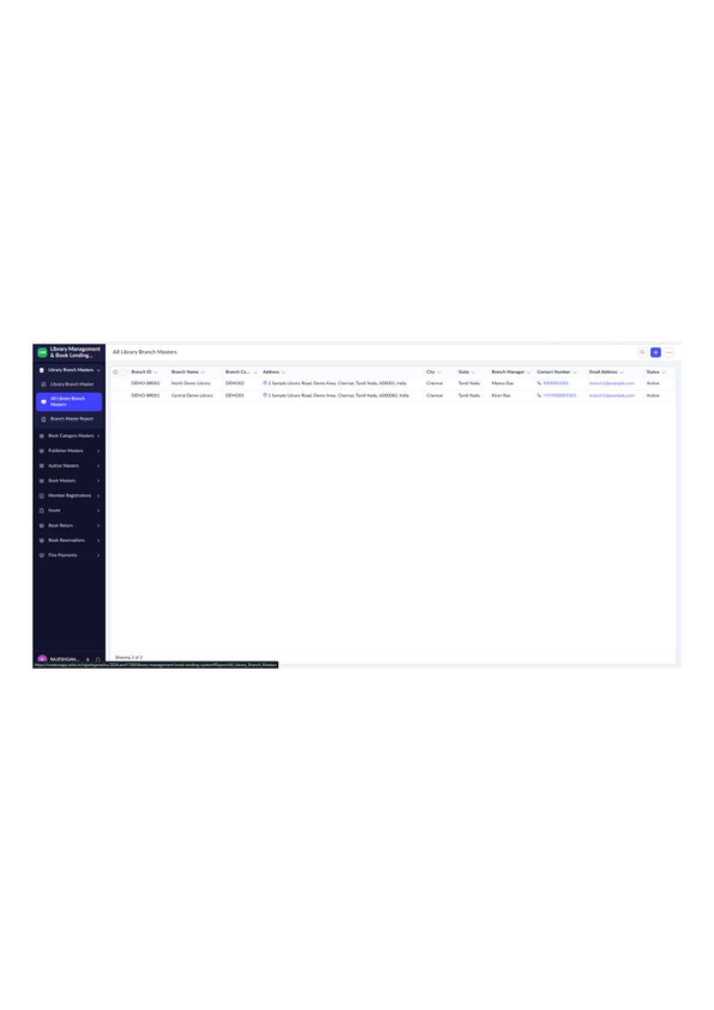
Figure 2: All Library Branch Masters – Report

LIBRARY MANAGEMENT SYSTEM
Branch Master Report – Map View
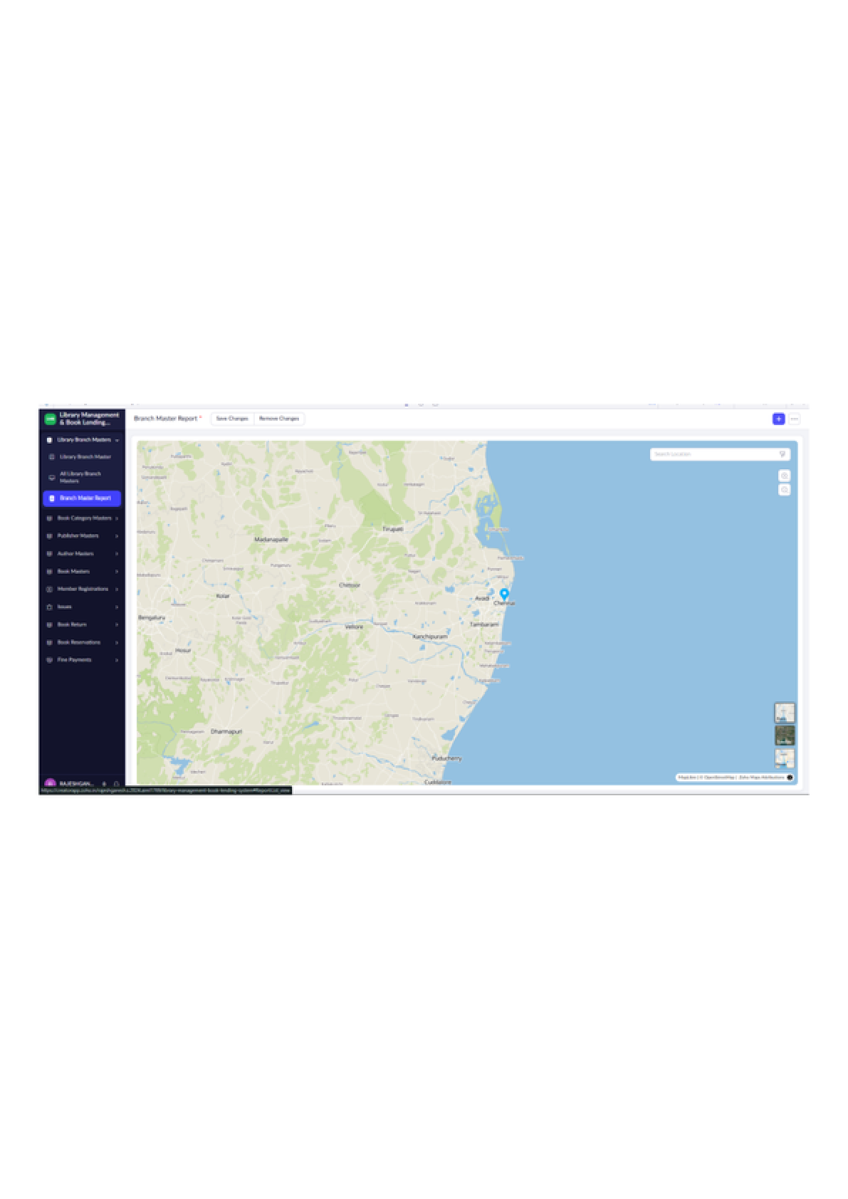
Figure 3: Branch Master Report – Map View

LIBRARY MANAGEMENT SYSTEM
Book Category Master – Entry Form
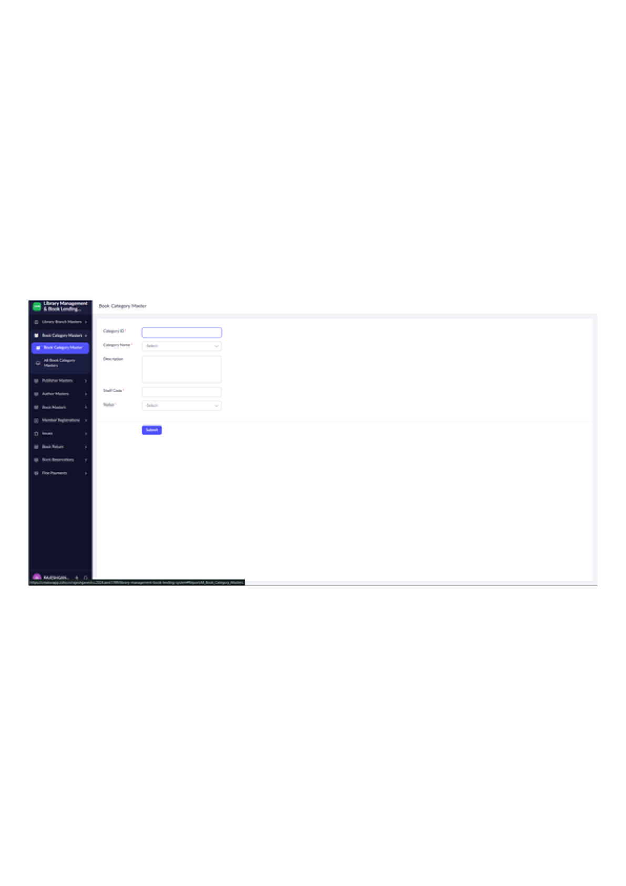
Figure 4: Book Category Master – Entry Form

LIBRARY MANAGEMENT SYSTEM
All Book Category Masters – Report
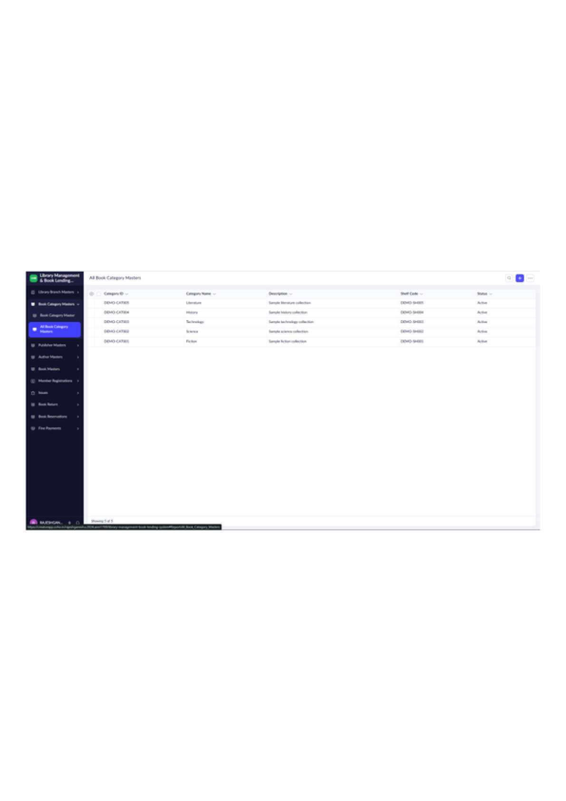
Figure 5: All Book Category Masters – Report

LIBRARY MANAGEMENT SYSTEM
Publisher Master – Entry Form
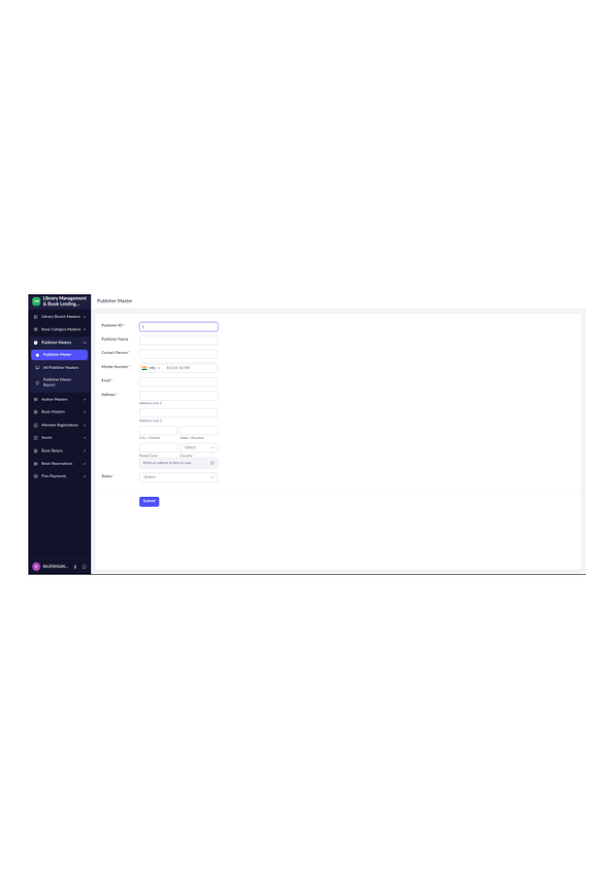
Figure 6: Publisher Master – Entry Form

LIBRARY MANAGEMENT SYSTEM
All Publisher Masters – Report
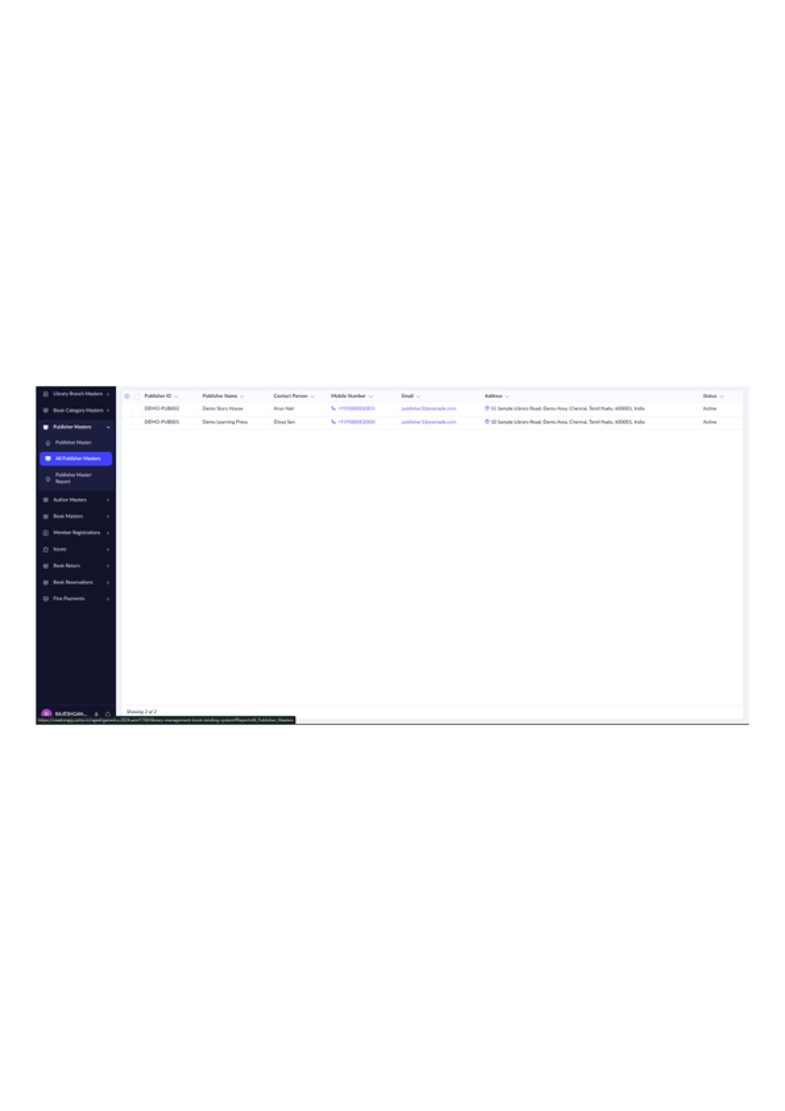
Figure 7: All Publisher Masters – Report

LIBRARY MANAGEMENT SYSTEM
Publisher Master Report
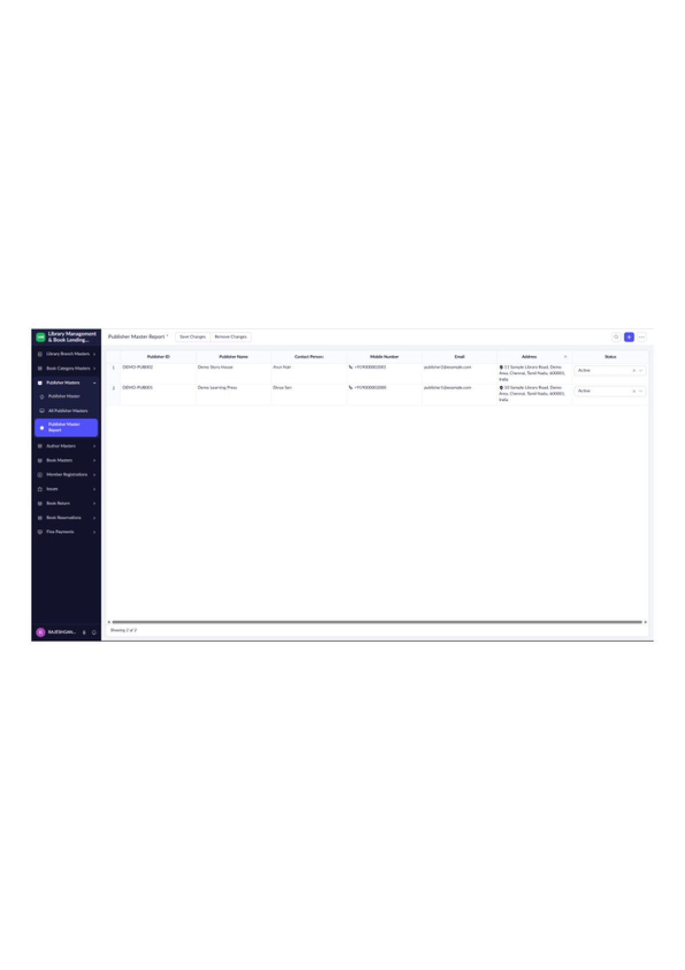
Figure 8: Publisher Master Report

LIBRARY MANAGEMENT SYSTEM
Author Master – Entry Form
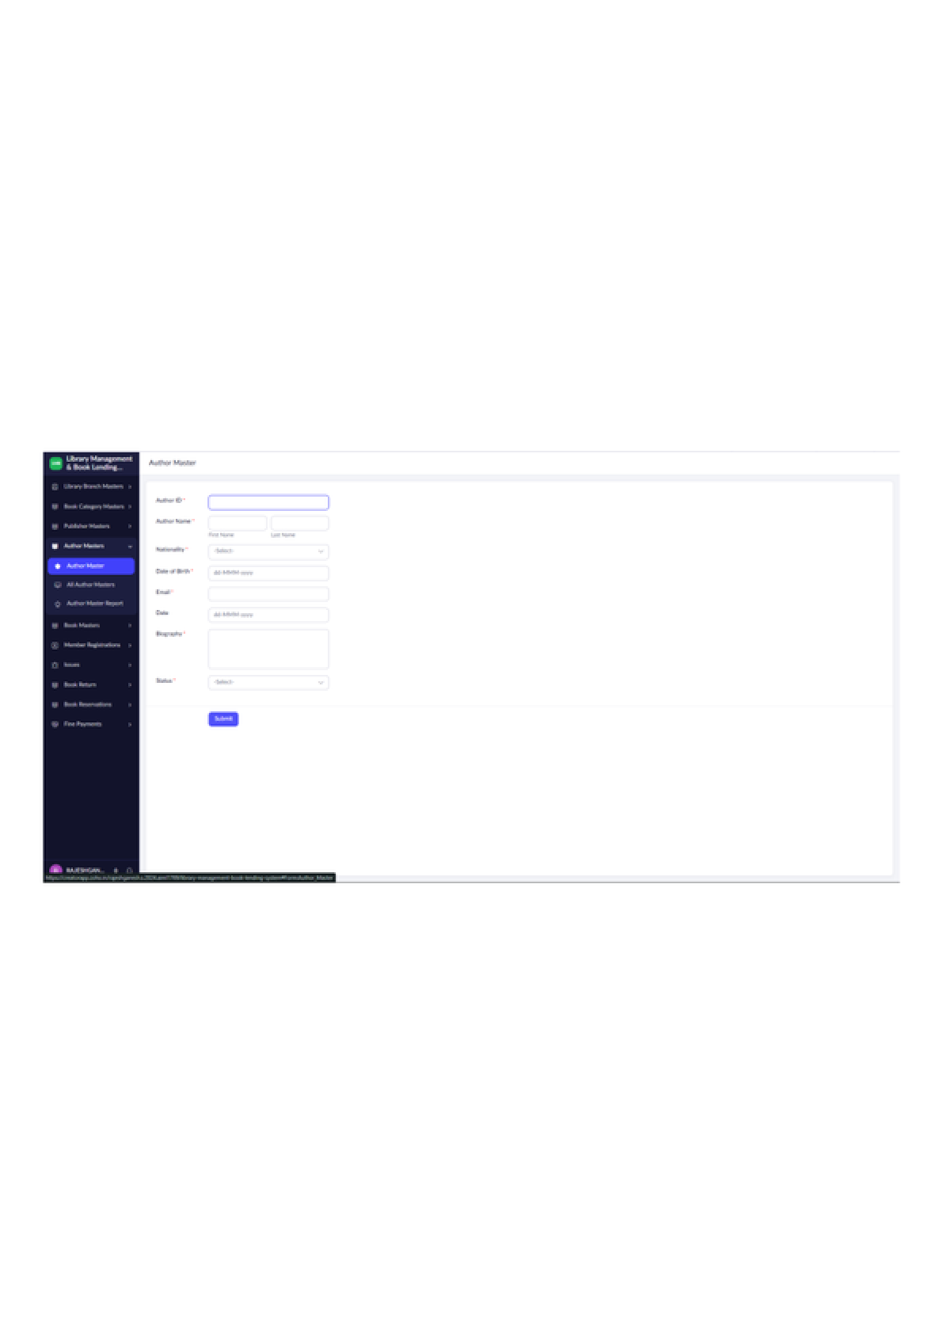
Figure 9: Author Master – Entry Form

LIBRARY MANAGEMENT SYSTEM
All Author Masters – Report
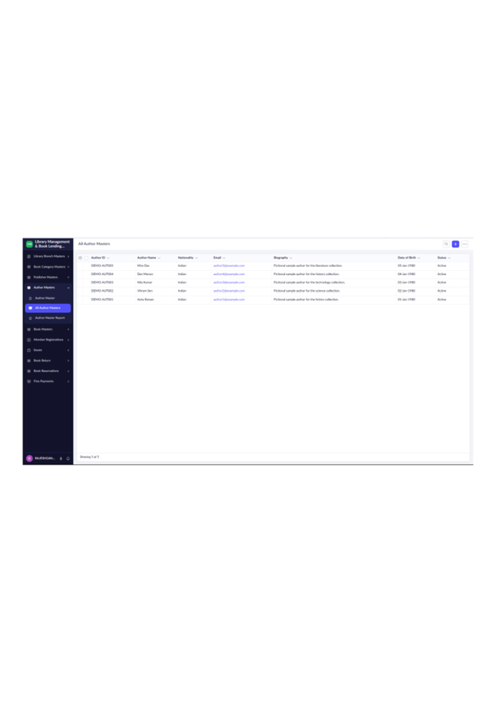
Figure 10: All Author Masters – Report

LIBRARY MANAGEMENT SYSTEM
Author Master Report
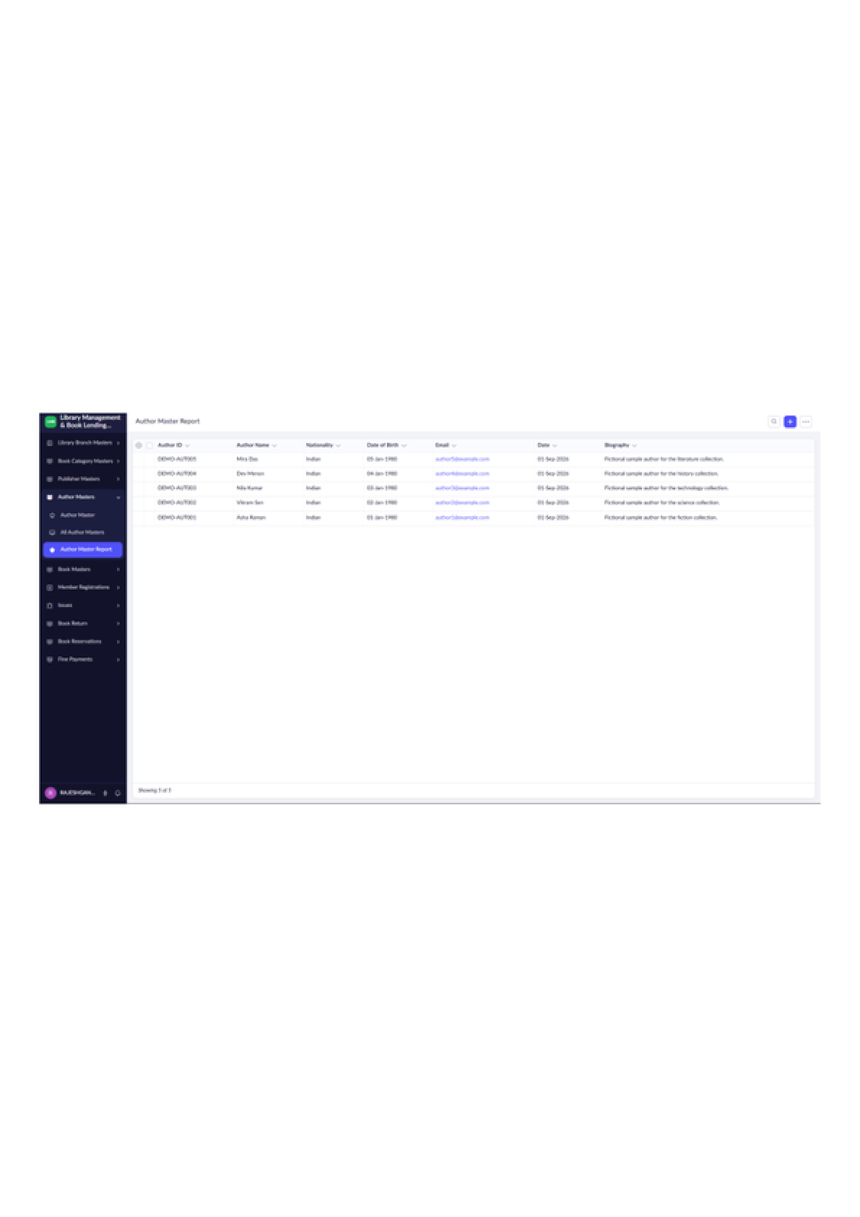
Figure 11: Author Master Report

LIBRARY MANAGEMENT SYSTEM
Book Master – Entry Form
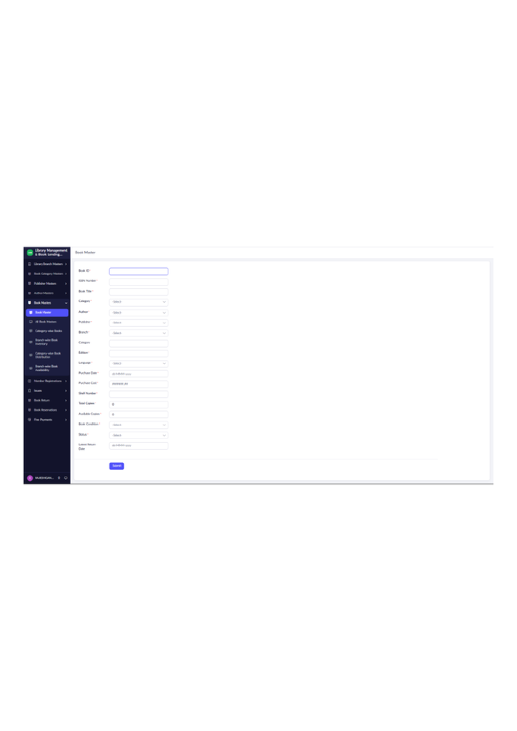
Figure 12: Book Master – Entry Form

LIBRARY MANAGEMENT SYSTEM
All Book Masters – Report
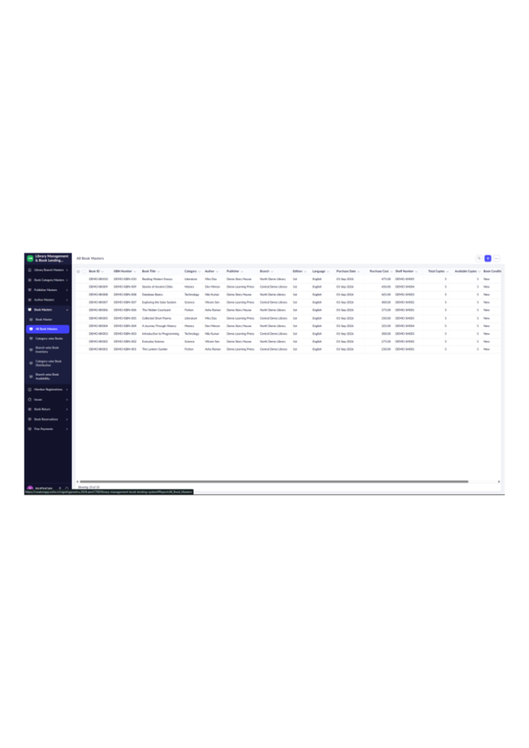
Figure 13: All Book Masters – Report

LIBRARY MANAGEMENT SYSTEM
Category-wise Books – Summary Report
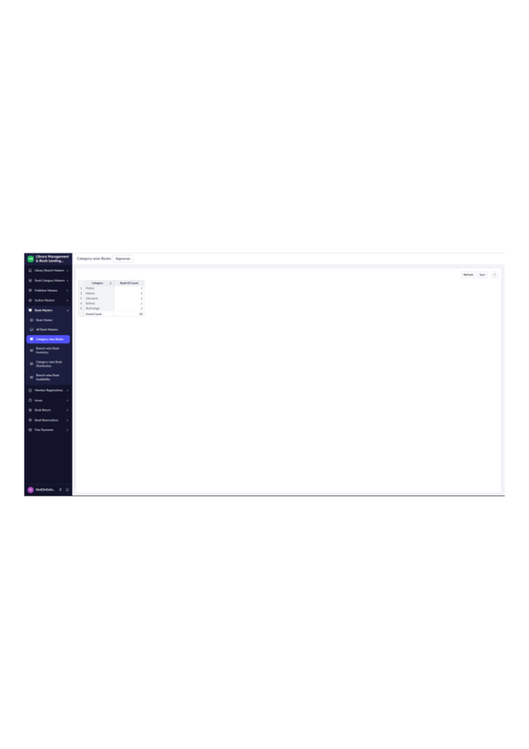
Figure 14: Category-wise Books – Summary Report

LIBRARY MANAGEMENT SYSTEM
Book Stock by Genre – Summary Report
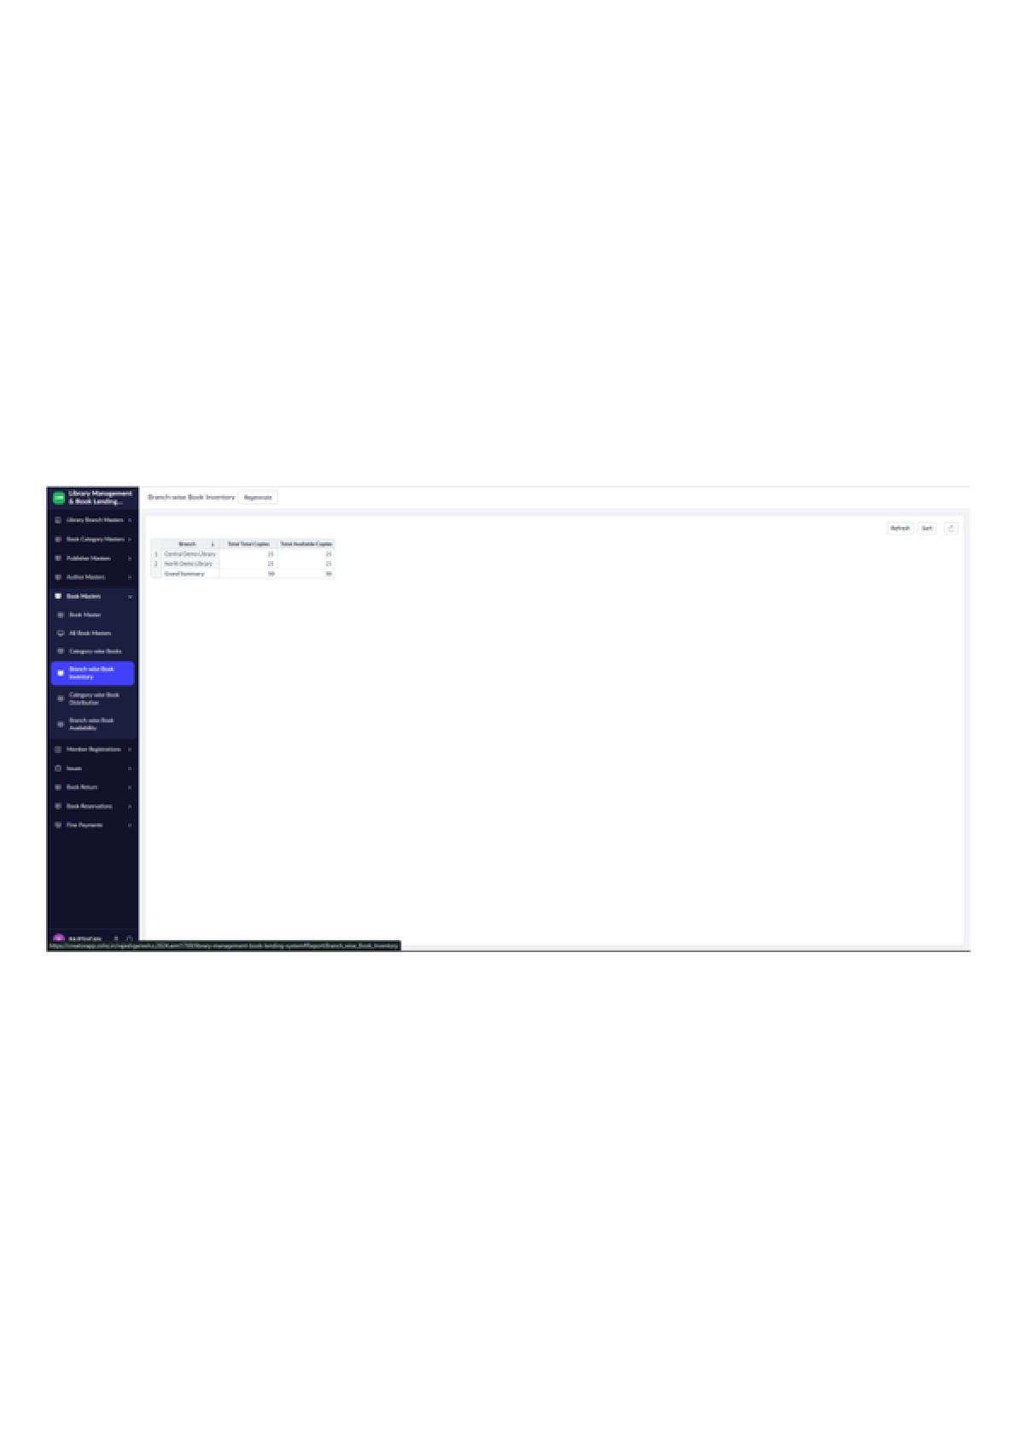
Figure 15: Book Stock by Genre – Summary Report

LIBRARY MANAGEMENT SYSTEM
Category-wise Book Distribution – Pie Chart
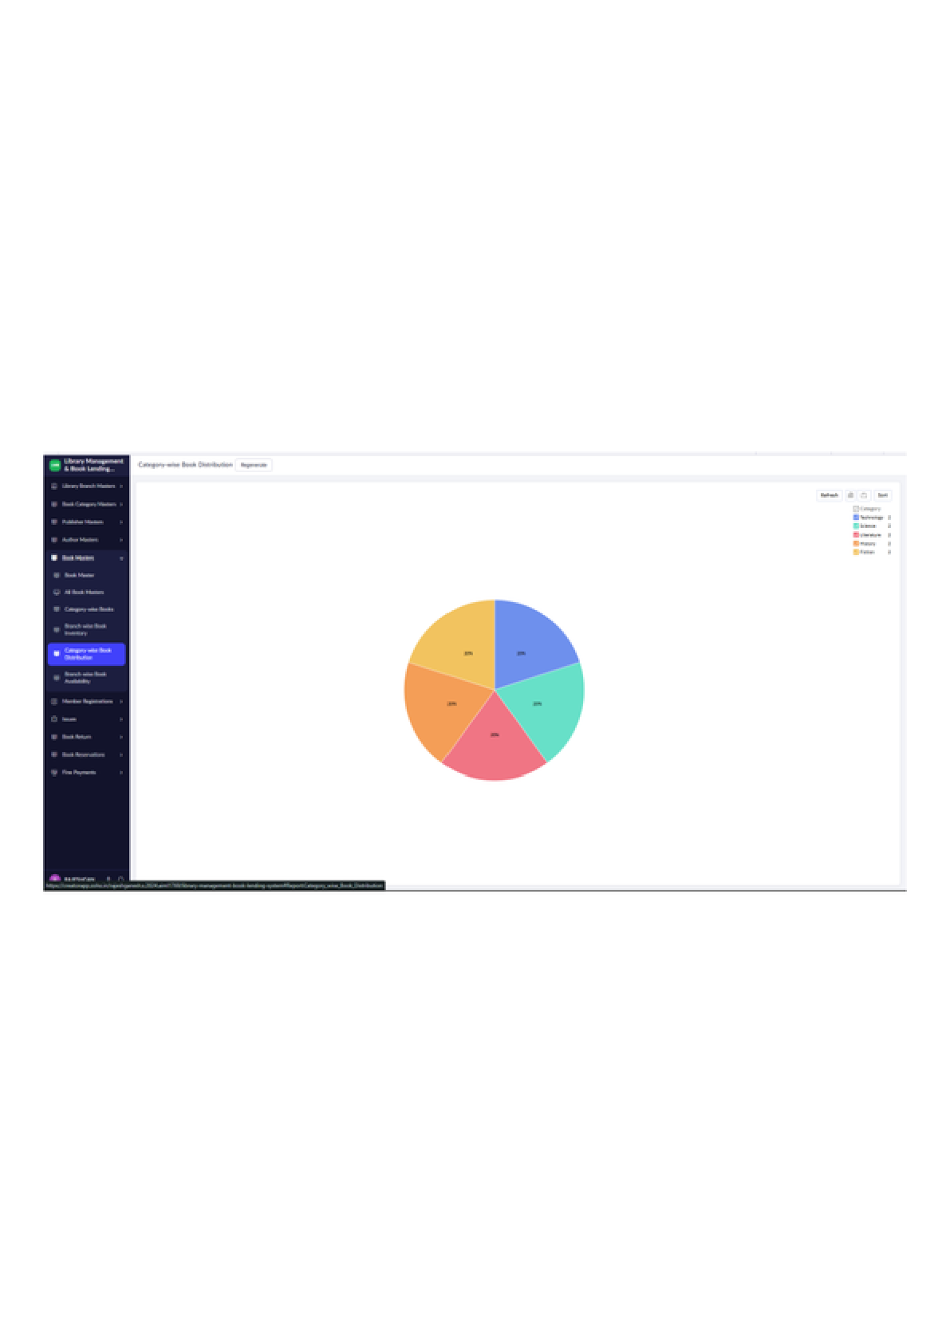
Figure 16: Category-wise Book Distribution – Pie Chart

LIBRARY MANAGEMENT SYSTEM
Book Stock Distribution – Bar Chart
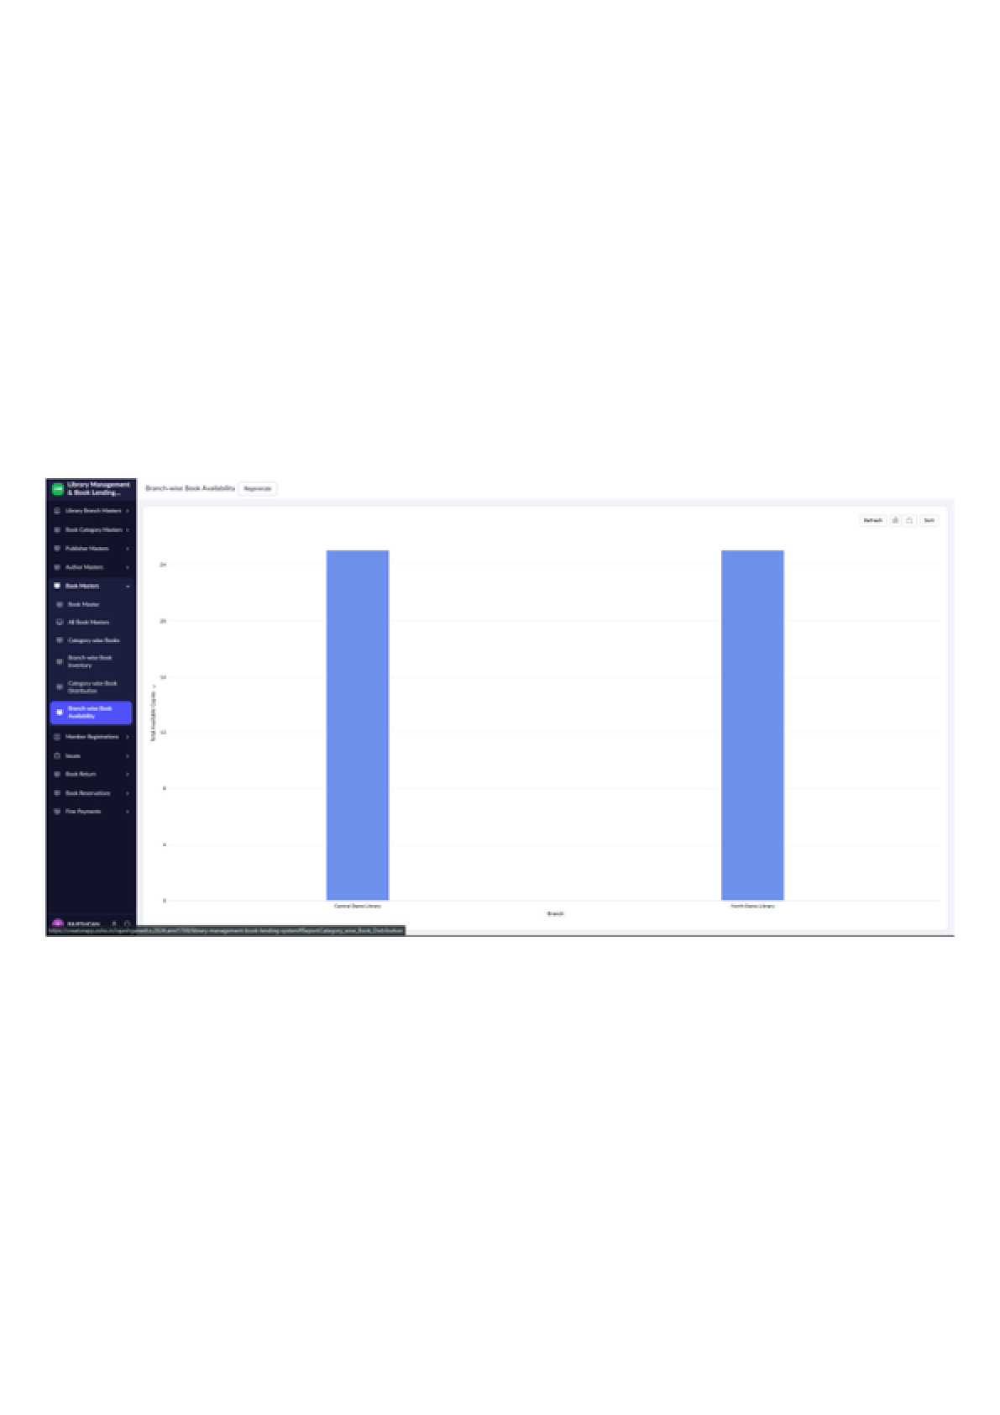
Figure 17: Book Stock Distribution – Bar Chart

LIBRARY MANAGEMENT SYSTEM
Member Registration – Entry Form
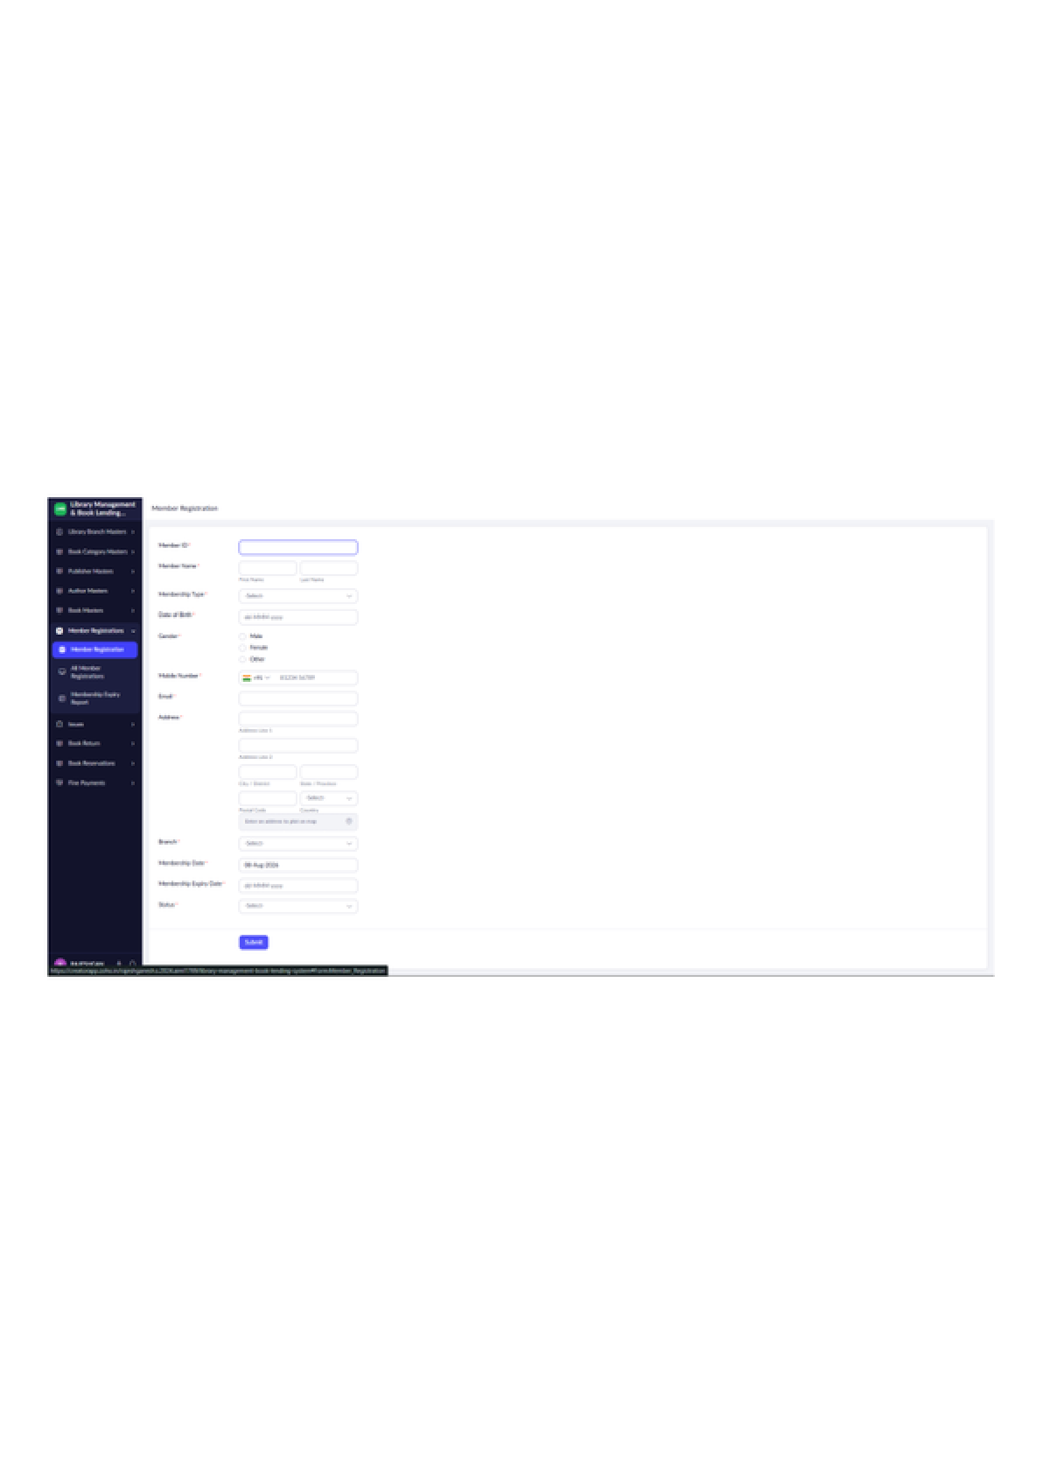
Figure 18: Member Registration – Entry Form

LIBRARY MANAGEMENT SYSTEM
All Member Registrations – Report
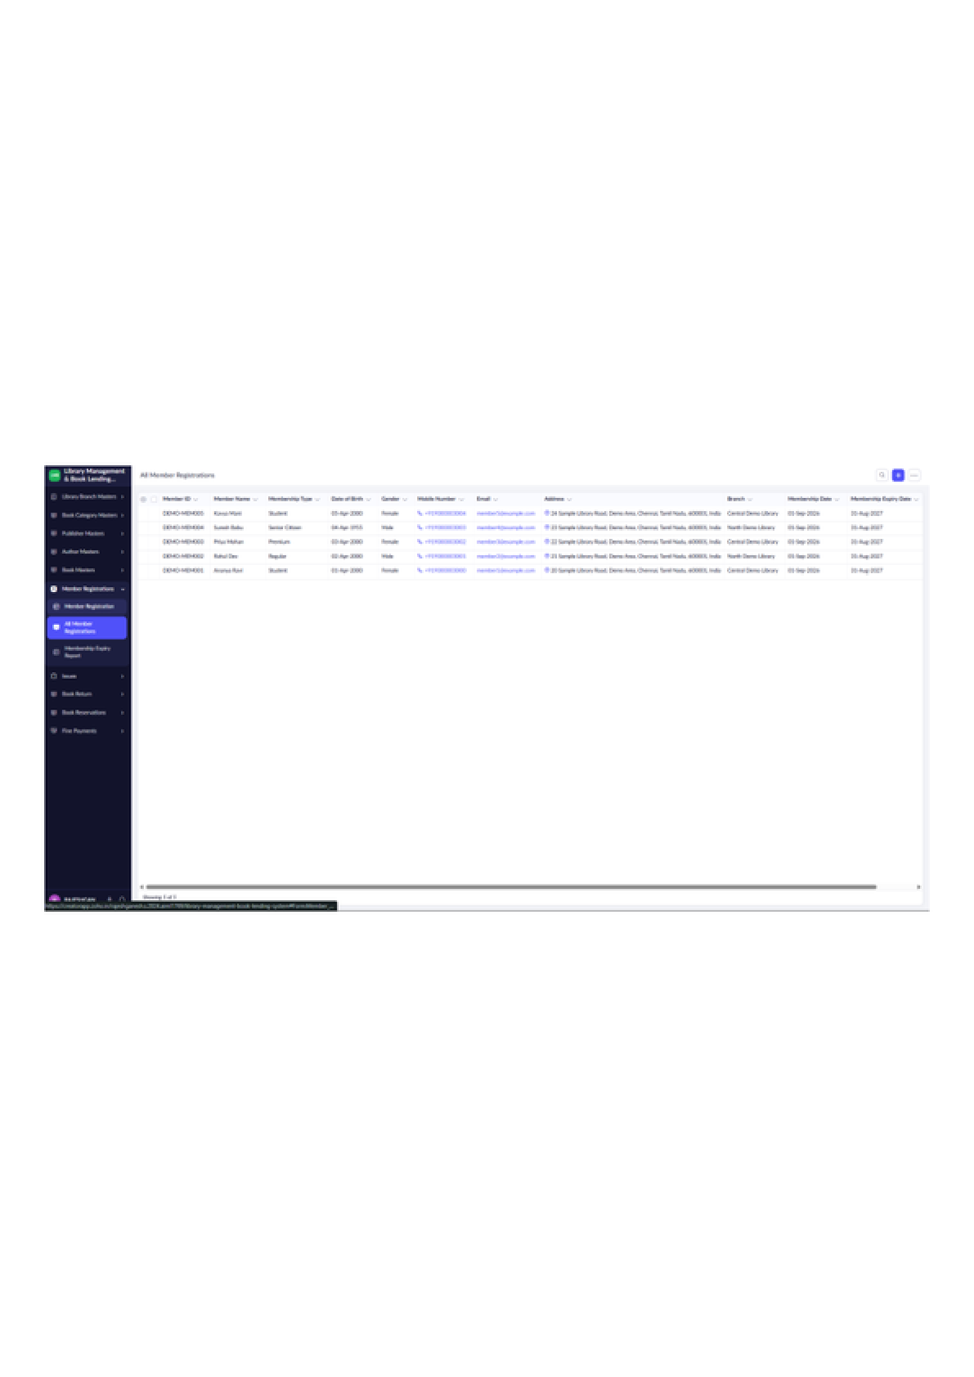
Figure 19: All Member Registrations – Report

LIBRARY MANAGEMENT SYSTEM
Book Issue – Entry Form
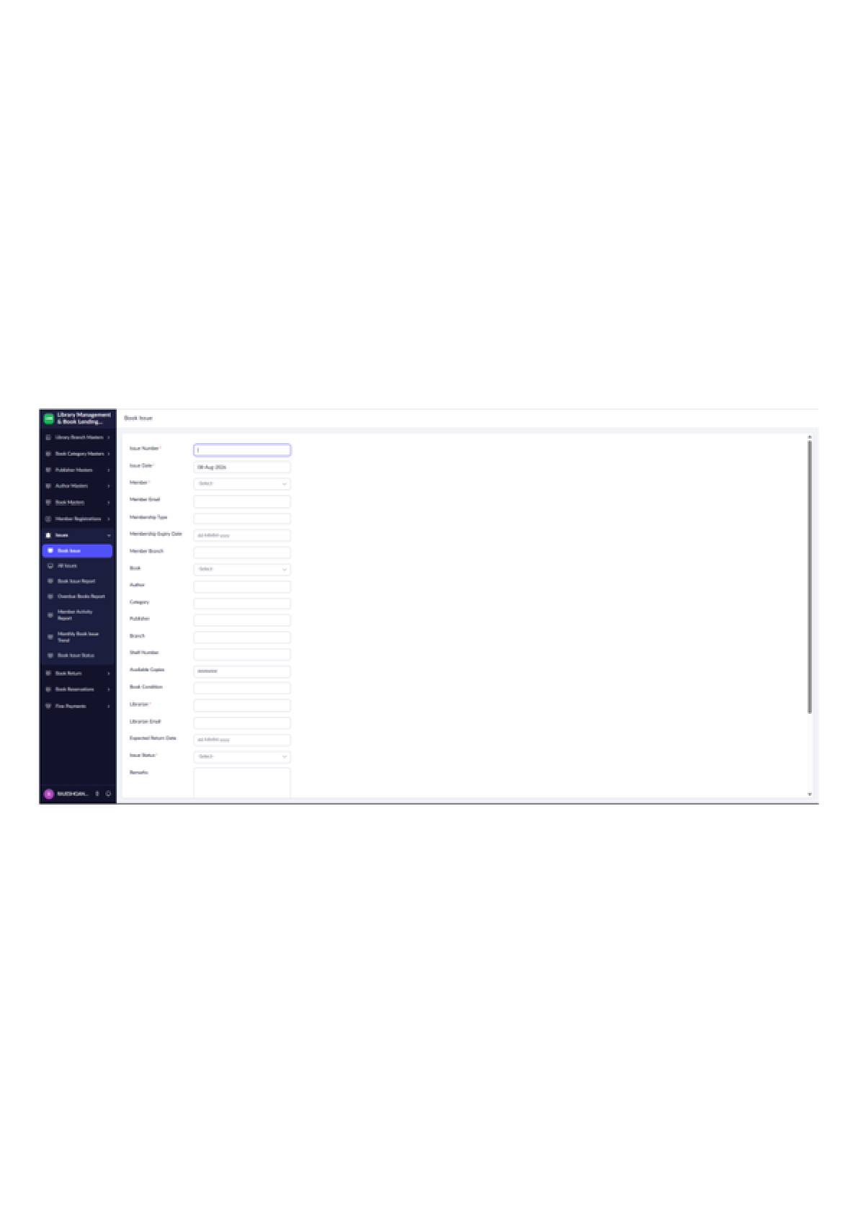
Figure 20: Book Issue – Entry Form

LIBRARY MANAGEMENT SYSTEM
All Book Issues – Report
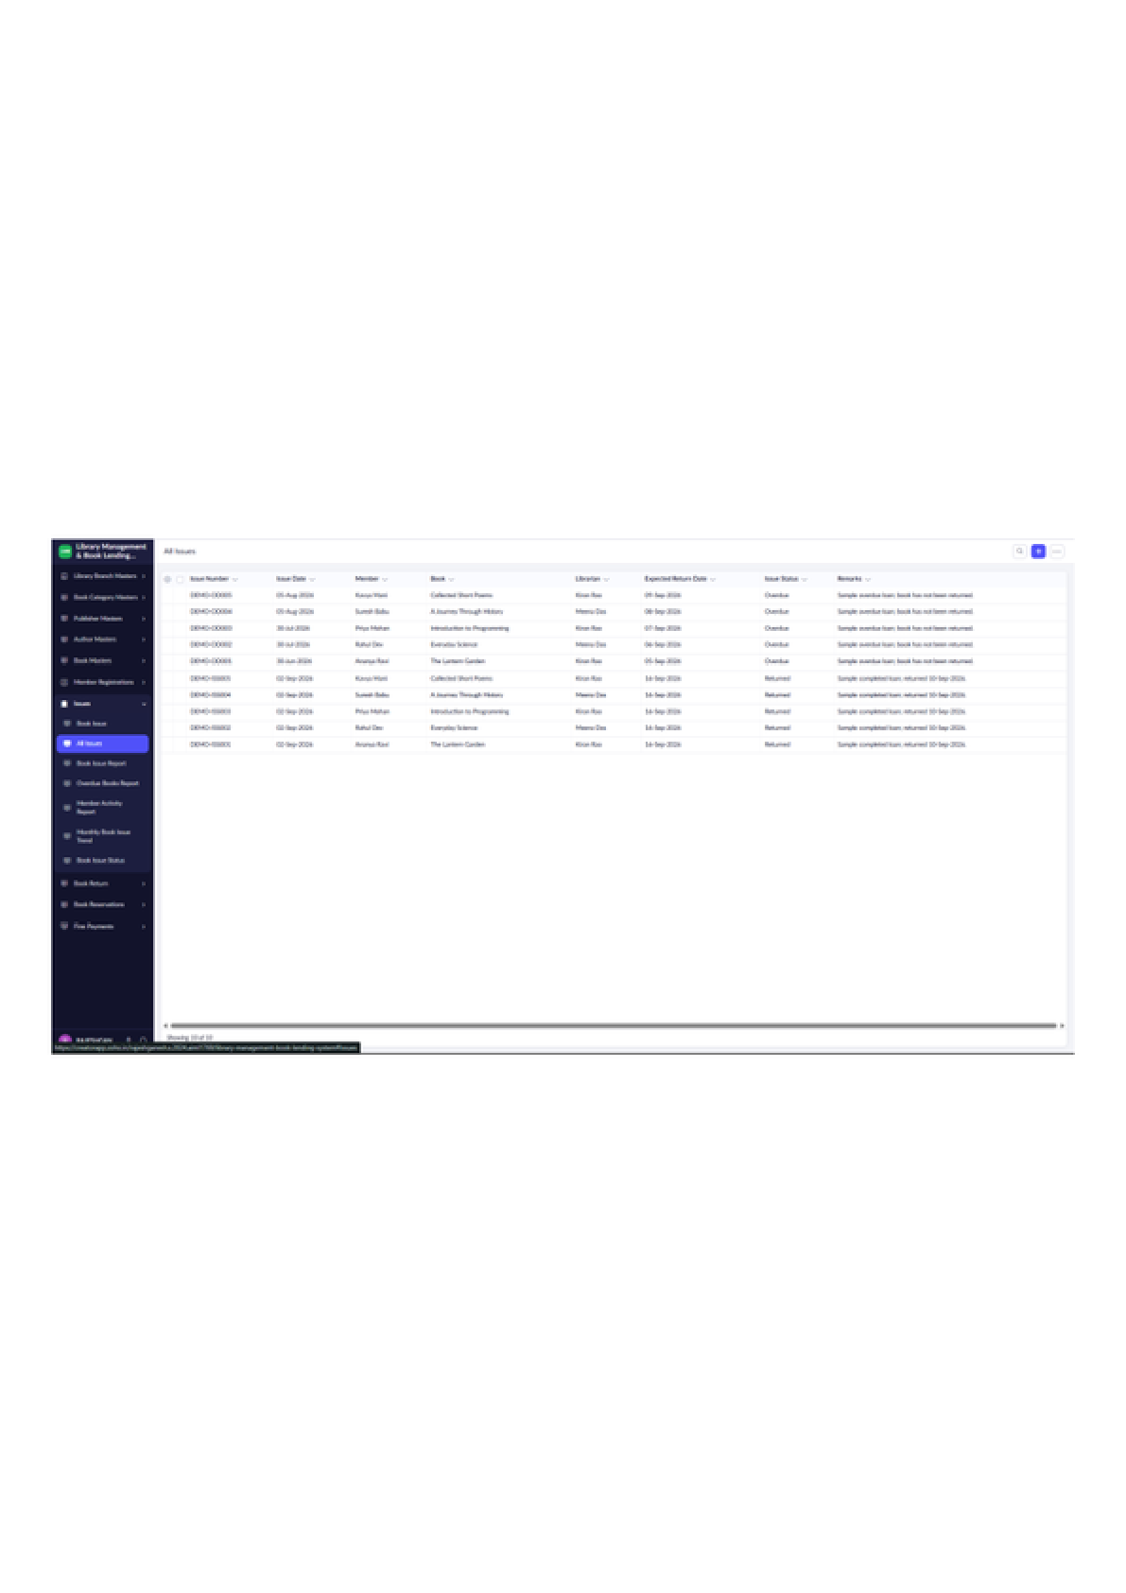
Figure 21: All Book Issues – Report

LIBRARY MANAGEMENT SYSTEM
Book Issue Report
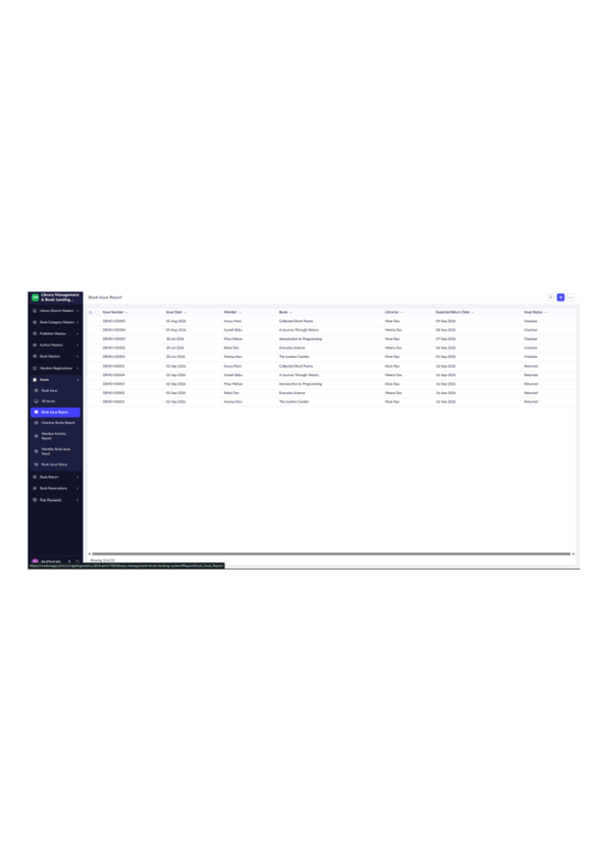
Figure 22: Book Issue Report

LIBRARY MANAGEMENT SYSTEM
Member Activity Report – Summary
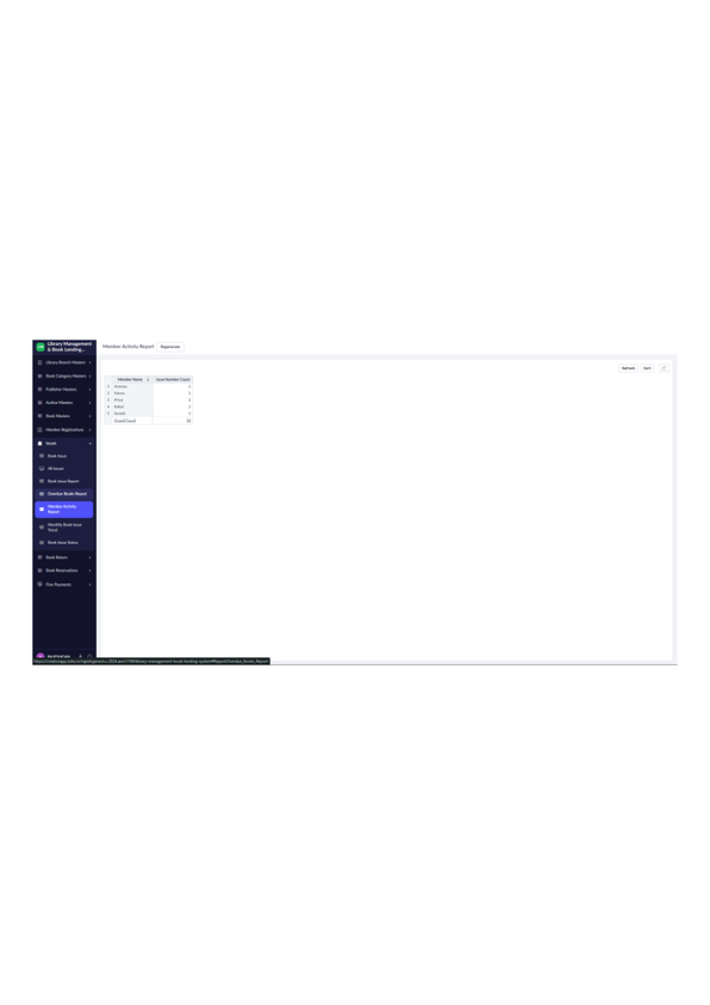
Figure 23: Member Activity Report – Summary

LIBRARY MANAGEMENT SYSTEM
Monthly Book Issue Trend – Line Chart
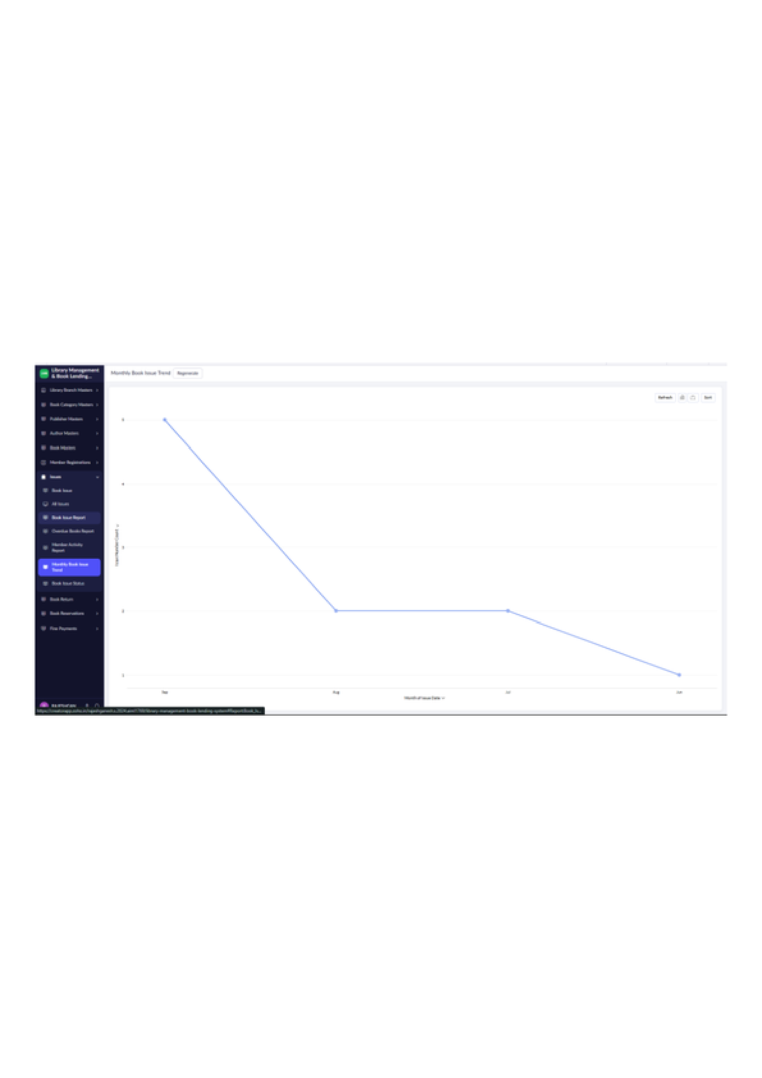
Figure 24: Monthly Book Issue Trend – Line Chart

LIBRARY MANAGEMENT SYSTEM
Book Issue Status – Kanban View
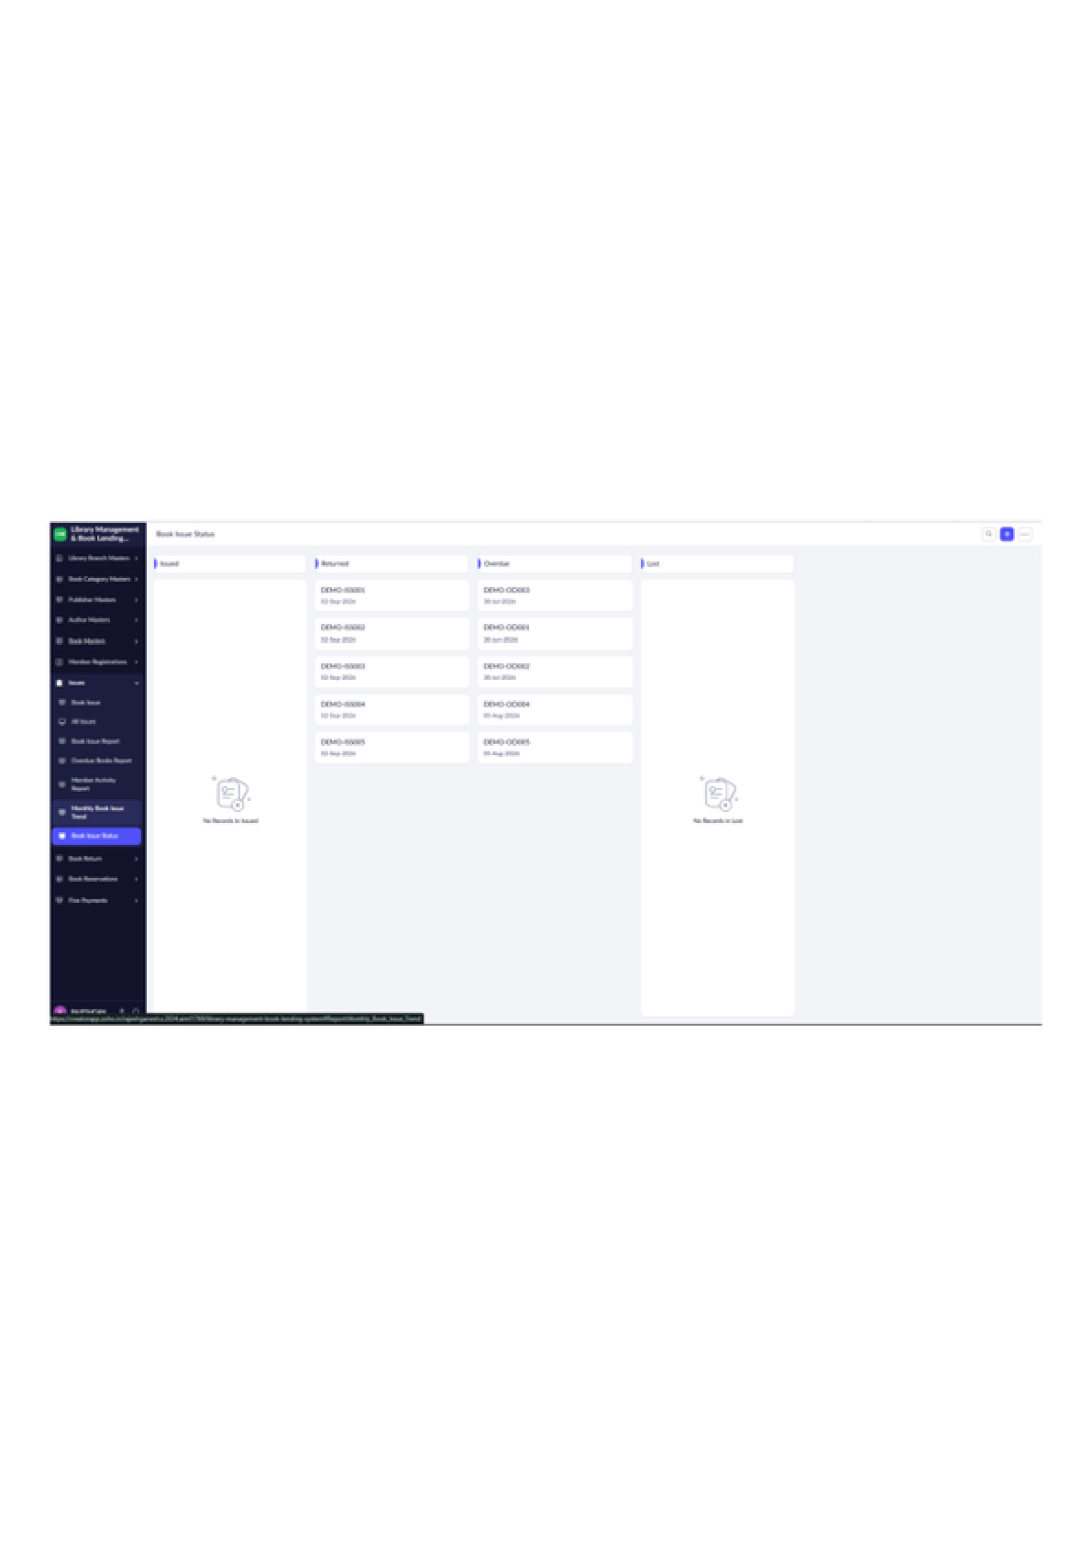
Figure 25: Book Issue Status – Kanban View

LIBRARY MANAGEMENT SYSTEM
Book Return – Entry Form
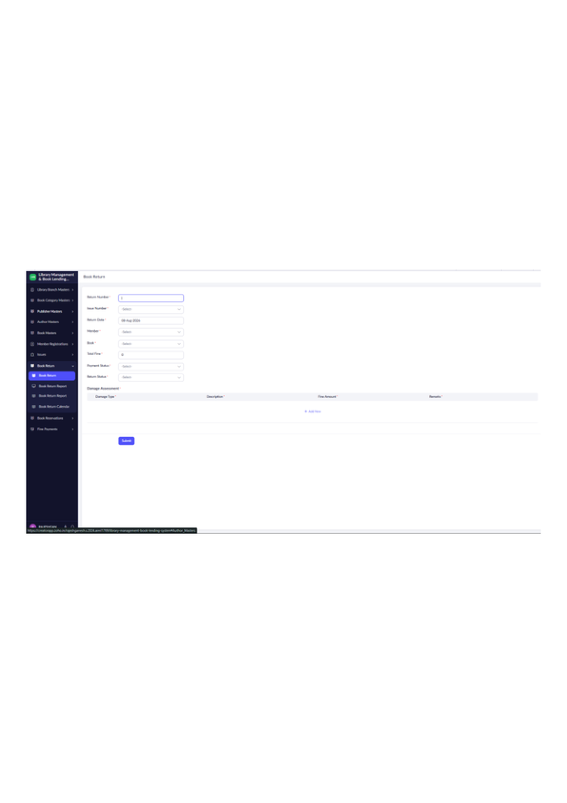
Figure 26: Book Return – Entry Form

LIBRARY MANAGEMENT SYSTEM
All Book Returns – Report
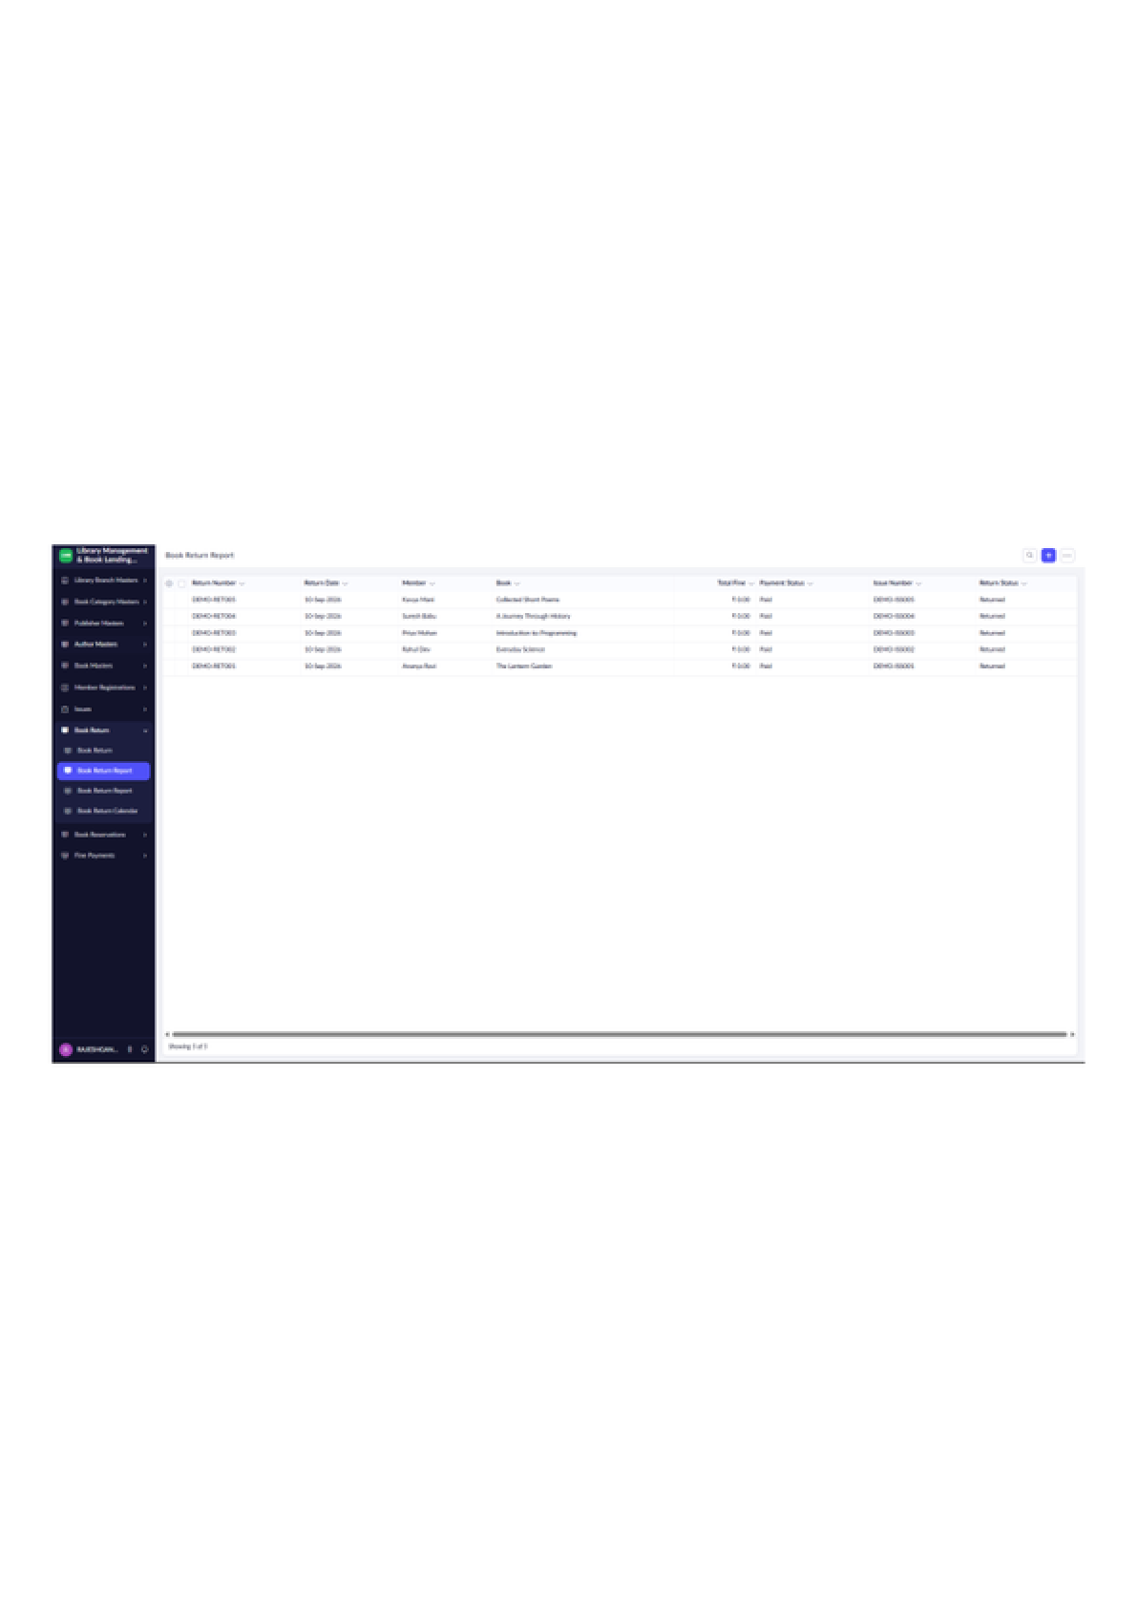
Figure 27: All Book Returns – Report

LIBRARY MANAGEMENT SYSTEM
Book Return Report
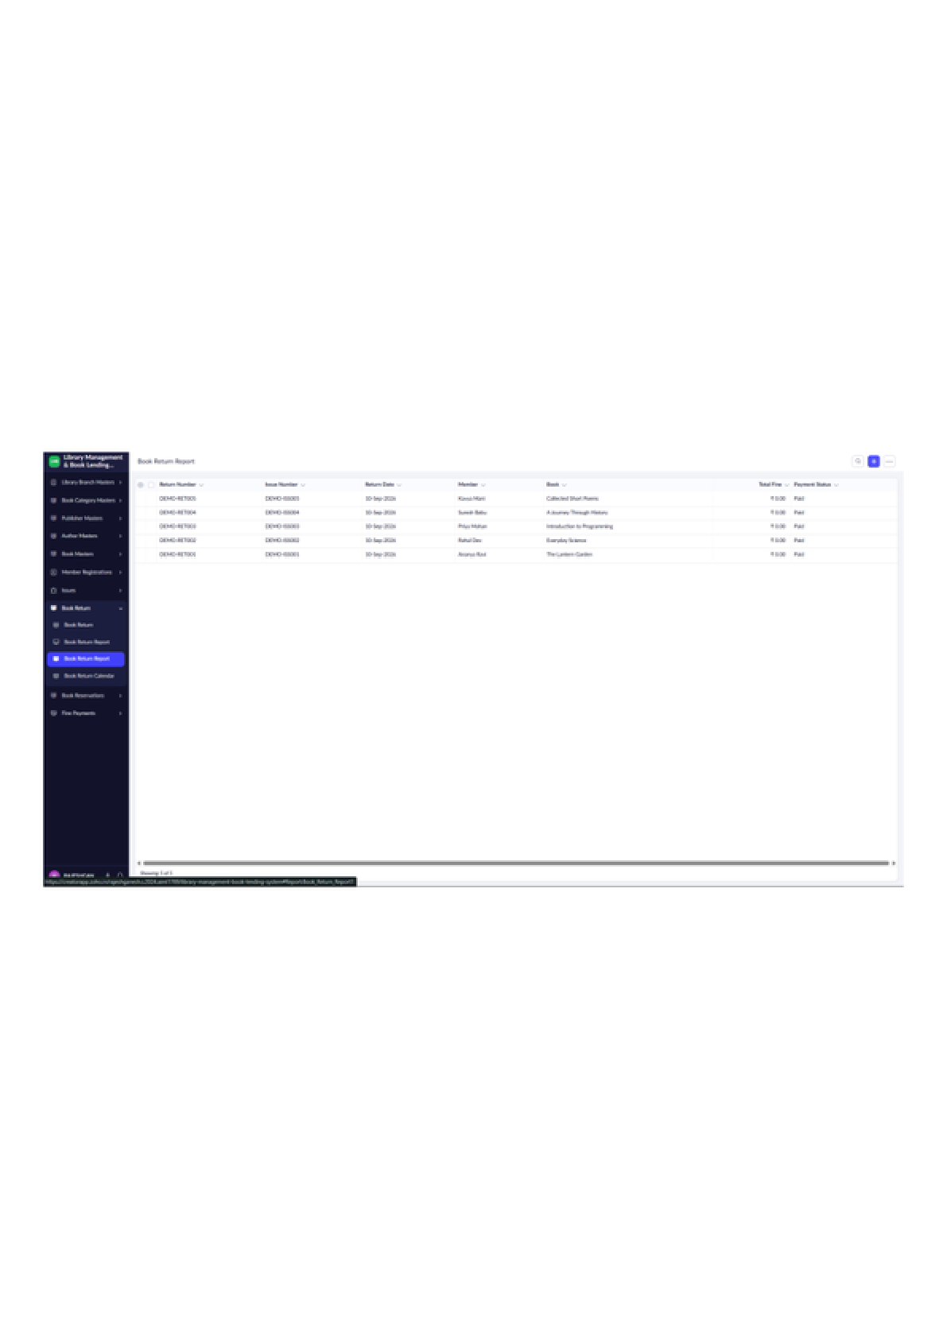
Figure 28: Book Return Report

LIBRARY MANAGEMENT SYSTEM
Book Return Calendar – Monthly View
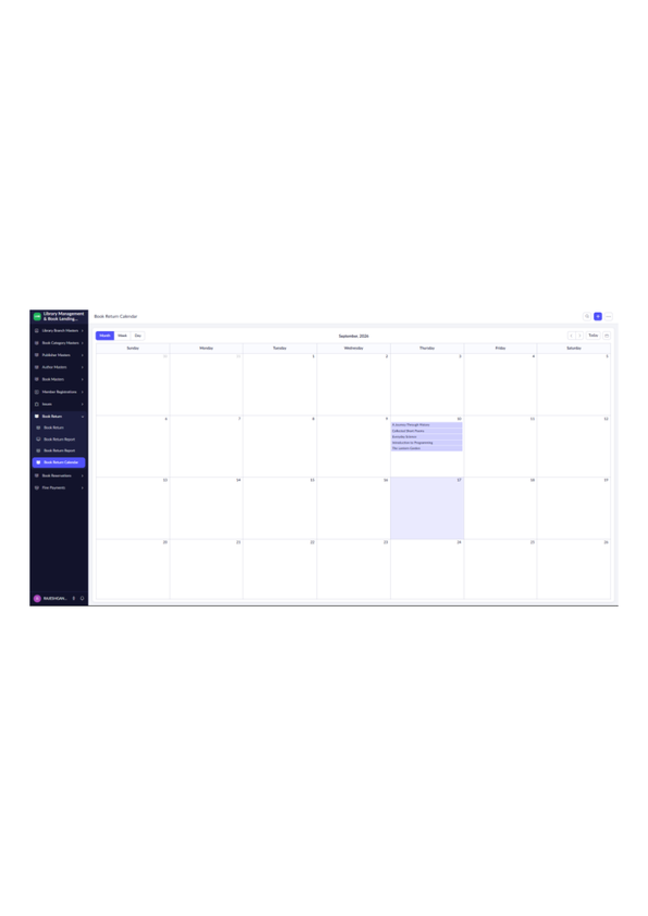
Figure 29: Book Return Calendar – Monthly View

LIBRARY MANAGEMENT SYSTEM
Book Reservation – Entry Form
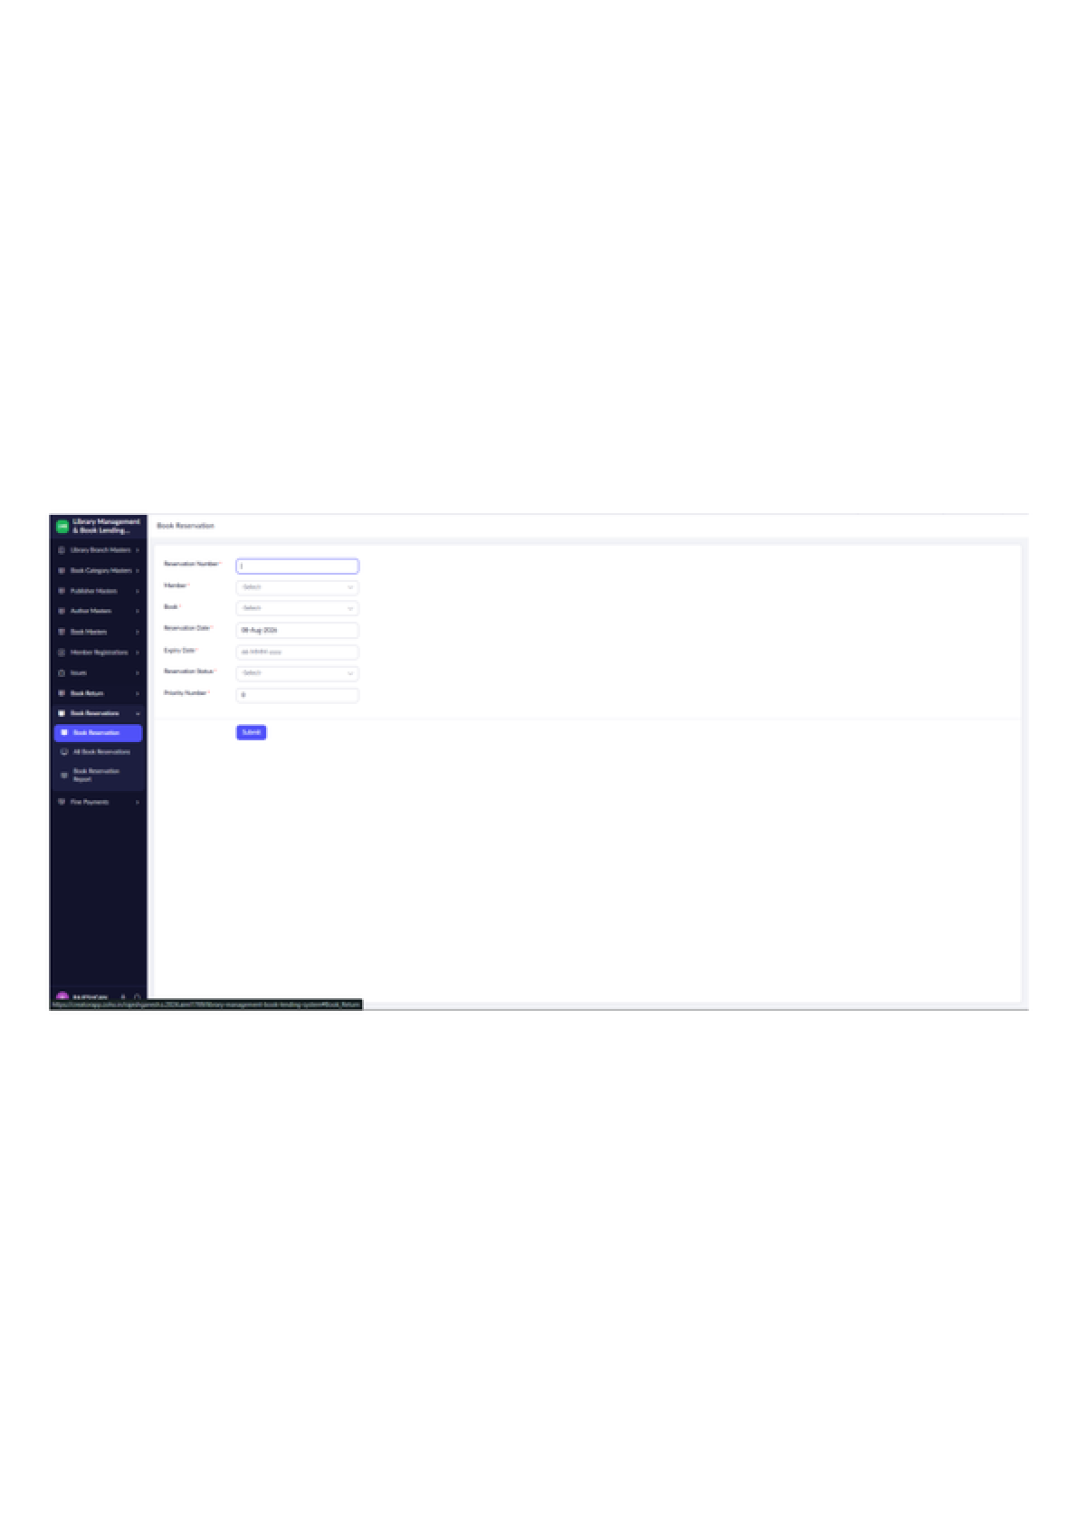
Figure 30: Book Reservation – Entry Form

LIBRARY MANAGEMENT SYSTEM
All Book Reservations – Report
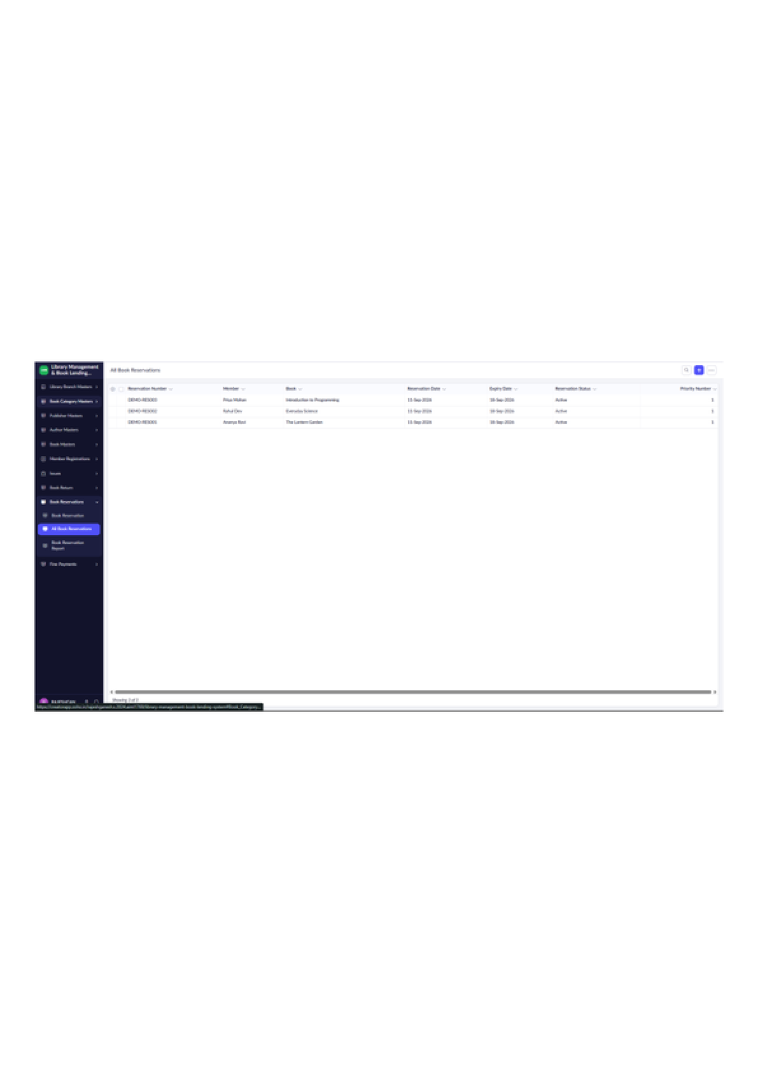
Figure 31: All Book Reservations – Report

LIBRARY MANAGEMENT SYSTEM
Book Reservation Report
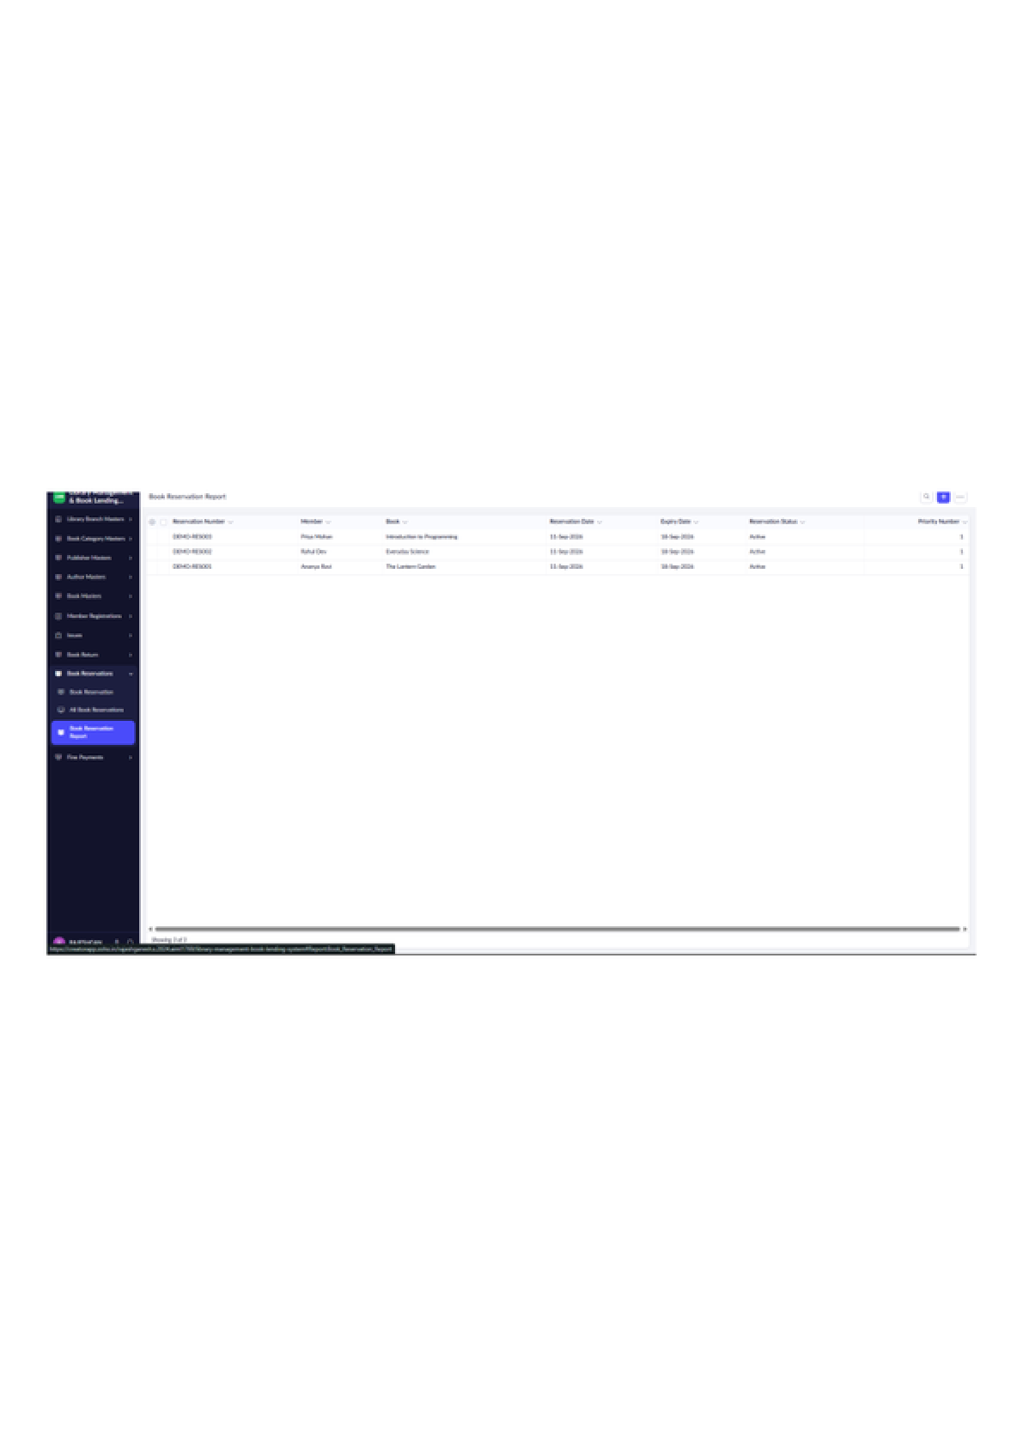
Figure 32: Book Reservation Report

LIBRARY MANAGEMENT SYSTEM
Fine Payment – Entry Form
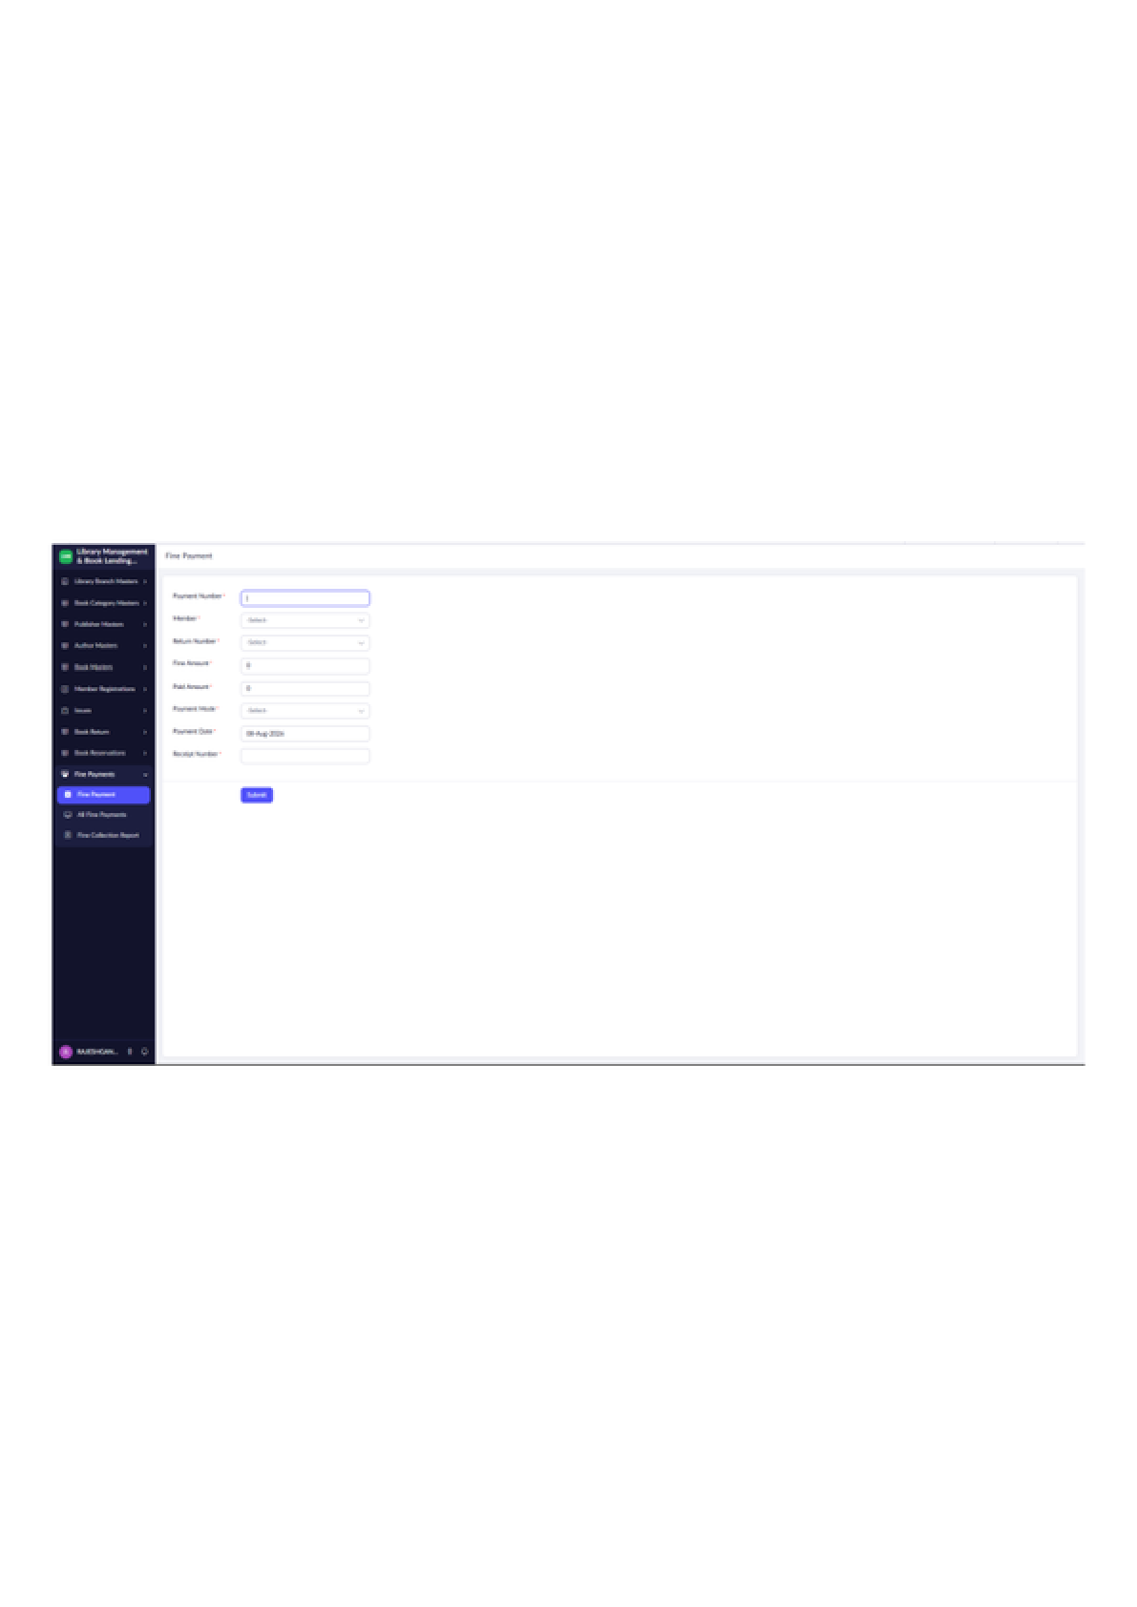
Figure 33: Fine Payment – Entry Form

LIBRARY MANAGEMENT SYSTEM
All Fine Payments – Report
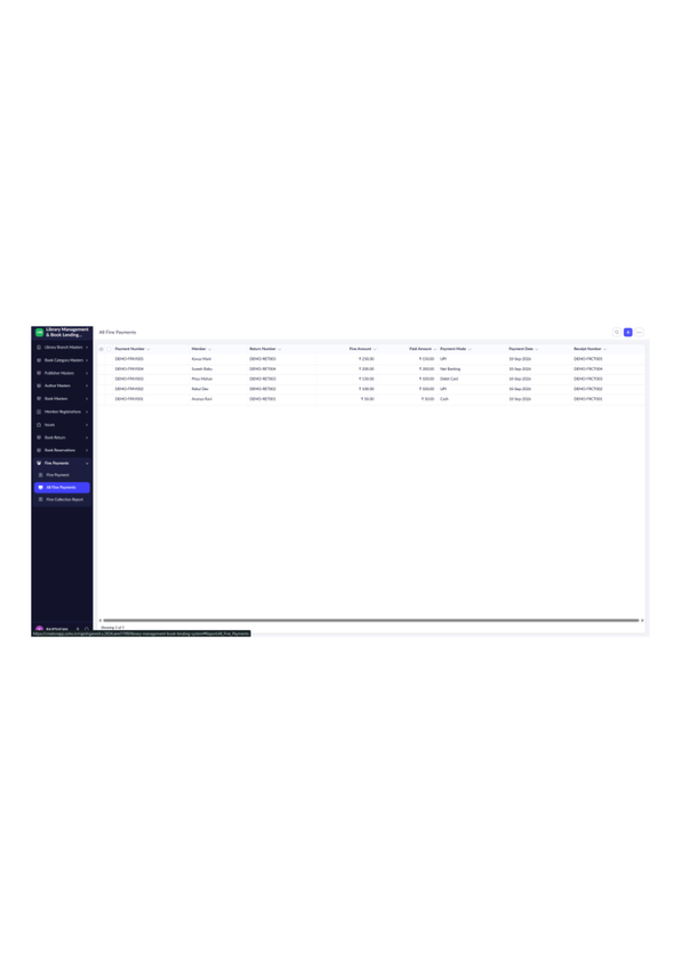
Figure 34: All Fine Payments – Report

LIBRARY MANAGEMENT SYSTEM
Fine Collection Report – Summary
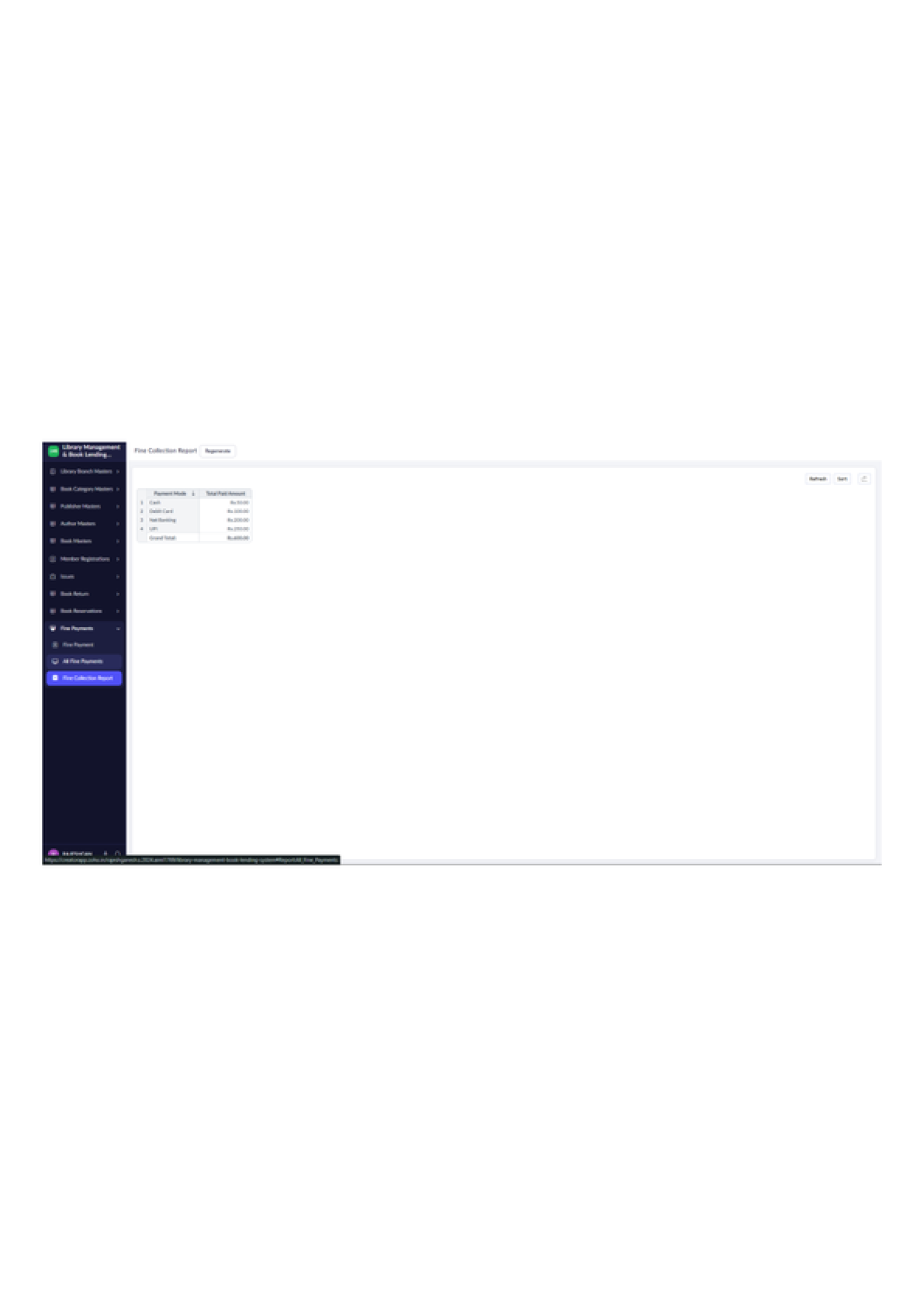
Figure 35: Fine Collection Report – Summary

